Test
1. current a) медь в) ток с) розетка
2. conductor а) провод в) привод с) проводник
3. circuit а) диод в) напряжение с) цепь
4. tube а) трубка в) пластина с) катод
5. completed а) открытый в) замкнутый с)непрерывный
6. to attract а) притягивать в)отталкивать с) останавливать
7. to permit а) разрешен в) запрещен с) проводить
8. device а) станок в) устройство с) машина
9. solid а) жидкость в) газ с)твердое тело
10. to use а) включать в) использовать с) работать
11. to require а) требование в) нагревать с) создавать
12. resistance а) напряжение в)сопротивление с) сила тока
13. to depend а) течь в) позволить с)зависеть
14. to change а) меняться в) меняться с) плавиться
15. copper а) золото в) железо с) медь
16. iron а) железо в) серебро с) утюг
17. value а) сопротивление в) проводить с) ценность
18. resistivity а) уд. сопротивление в) ковкость с) кипение
19. melting point а) точка кипения в) точка плавления с) точка замерзания
20. compare а) уравнивать в) сочетать с) сравнить
Прочтите и переведите текст, выполните упражнения
Electric Power and Machinery.

The field of electric power is concerned with the design and operation of systems for generating, transmitting, and distributing electric power Engineers in this field have brought about several important developments since the late 1970s. One of these is the ability to transmit power at extremely high voltages in both the direct current (DC) and alternating current (AC) modes, reducing power losses proportionately. Another is the real -time control of power generation, transmission, and distribution, using computers to analyse the data fed back from the power system to a central station and thereby optimizing the efficiency of the system while it is in operation.
A significant advance in the engineering of electric machinery has been the introduction of electronic controls that enable AC motors to run at variable speeds by adjusting the frequency of the current fed into them. DC motors have also been made to run more efficiently this way.

Electrical Machine:
A device capable of inter-conversion between electrical energy and mechanical energy is called Electrical Machine.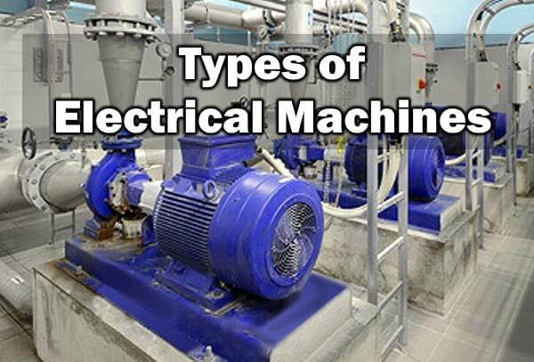
In simple words, an electrical machine converts electrical energy into mechanical energy & vice versa. A transformer is also an Electrical machine with an exception that it converts voltage & current levels.

Types of Electrical Machines:
Electrical machines are classified into two main types i.e.
- Stationary Electrical Machines
- Dynamic Electrical Machines

Stationary Electrical Machines:
A stationary electrical machine is such kind of machine which does not have any moving parts & they remain stationary throughout its operation.

Transformer:
A transformer is a stationary electrical machine, which does not have any moving parts. It is a machine because there is a conversion between electrical & magnetic energy between the windings of the transformer.
It converts electrical energy into magnetic energy & again into electrical energy with increasing or decreasing the AC voltage/current level & maintaining the electrical frequency constant.
It has two windings i.e. Primary & secondary winding. Both winding are wounded around a stationary iron core.
The varying AC current is applied to the primary winding, which creates a varying magnetic flux in the core of the transformer. This varying magnetic flux induces an EMF in the secondary winding of the transformer, resulting in an AC current at the output.

Dynamic Electrical Machines:
Such type of machines consists of moving parts as well as stationary parts.
There are two types of Dynamic electrical machines i.e.
- Electrical Motor
- Electrical Generator

Electrical Motor:
A motor is a type of dynamic machine which converts electrical energy into mechanical energy.
Electrical motors have a moving part called rotor & a stationary part called stator.
Electrical motors generate a mechanical force due to the interaction between the magnetic field and current in a conductor.
There are two main types of Electrical motors i.e. DC motor & AC motors.

DC Motors:
Wherever a current-carrying conductor is placed inside a magnetic field, it experiences a mechanical force. The DC motor operates on this principle. The rotor is made up of multiple loops of conductors, which is supplied by a DC source. The rotor is placed in a magnetic field. The conductor experiences a force due to which the rotor rotates.

AC Motors:
In AC motors, the stator is made up of winding which is connected to the AC voltage supply. It creates a rotating magnetic field.
The rotor is made up of a conductor which can easily conduct electricity. The rotor is placed inside the stator.
Unlike DC motor, the electrical supply is connected with the stator of AC motors.
Due to the rotating magnetic field produced by stator winding, an emf is induced in the rotor. This, in turn, creates its own magnetic field opposing the stator’s magnetic field according to Lenz’s law. This magnetic field tries to cancel out the stator’s rotating magnetic field by rotating the rotor with exact same rotation speed.

Electrical Generators:
Generators are such types of electrical machines which converts mechanical energy into electrical energy.
Its operation is exactly opposite to the electrical motor. According to faraday’s law, a conductor placed inside a varying magnetic field will experience an induced emf. In other words, moving a conductor in a static magnetic field will induce emf in the conductor.
The rotor is rotated inside a magnetic field by any means known as a prime mover. The resultant induced current (electrical energy) flows out through the conductor.

Put the syllables in the correct order to get the words.

- ti, li, app,on,ca.
- ment, de, lop, ve.
- ver, si, di, ty.
- ne, chi, ma, ry.
- mi, ti, com, ni, ca, ons.

Electronics.

Find ten words in the square.

i | a | s | t | c | r | e | a | p | c
n | n | a | v | a | k | i | t | e | a
c | o | d | a | p | s | d | e | r | r
l | e | v | i | a | e | f | g | f | r
u | h | a | k | c | p | i | m | o | y
d | o | n | p | i | a | r | u | r | v
e | w | c | x | t | r | t | y | m | z
a | b | e | c | o | a | u | i | f | h
s | i | d | o | r | t | b | p | o | r
s | e | m | b | l | e | e | s | y | n

Переносить; показание; выполнять; раздельный; трубка;
конденсатор (радио); монтировать; продвинутый; включать (в себя); создавать.
Find the translations of the English words in the right column.

1. application a) получать
2. to transmit b) связывать
3. to receive c) задача
4. to store d) сложный
5. task e) применение
6. digital f) волна
7. wave g) состоять
8. to consist h) передавать
9. to connect i) цифровой
10. complex j) хранить

