Рецепт плова на английском
Рецепт приготовления плова - сытного и вкусного восточного блюда на английском языке с переводом.
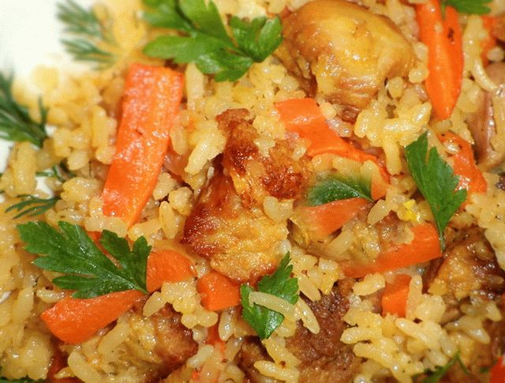
Eastern dish of pilaf is very popular in our country. The hostess passed from generation to generation the secrets of its preparation. In Muslim countries often use beef, but to us familiar taste of pork.

Recipe pilaf
Each family has its own secrets of cooking pilaf. This dish is loved the most by the people in the East, but also on our tables it can be found quite often. There is a saying that varieties of pilaf recipe as much as Muslim cities.

Ingredients:
- pork (500 grams);
- carrots (2 pieces);
- onions (2-3 pieces);
- rice (1.5 cups);
- turmeric (1 tea spoon);
- Bay leaf;
- salt;
- vegetable oil;
- pepper;
- coriander;
- garlic (3 cloves).

Method of preparation
Rinse the rice under running water. Pour boiled water and let it infuse for a few hours.
Clean off top of carrot peel and grate on a medium grater. Chop the onion into pieces.
Across the grain slice the meat into large pieces.
Take a deep pan, pour her a large amount of vegetable oil, add pork, onion and carrot and gently fry over a medium heat.
Drain rice with water and pour it in the pan. A bit of fry before formation of a light crust on the meat. Pour water on the basis of a ratio of 1: 2.
Add salt and pepper and spices. Bring to a boil, then reduce heat.
Chop the garlic and put on top of the pilaf at the end of cooking.
Cooking time about half an hour. At the end it is better to wrap the container with pilaf for the best steaming.
Bon appetit!
Cutlets "Pozharsky" - one of the masterpieces of Russian cuisine. Prepare them flavorful sauce and surprise all palates.

The recipes of Russian dishes – cutlets "Pozharsky"
The masterpiece of Russian cuisine can shamelessly call cutlets "Pozharsky". Juicy, soft and airy they just melt in your mouth. This recipe is written in my cookbook.

Ingredients:
- chicken breast on the bone – 1 kg;
- white bread – 100 grams;
- milk – half Cup;
- butter – 50 grams;
- breadcrumbs for breading;
- black pepper;
- salt.

For the sauce:
- mushrooms – 150 grams;
- onion – 1 piece;
- broth from chicken bones – 1 Cup;
- butter – 50 grams;
- flour – 1 tablespoon.

Method of preparation
The meat separated from the bones. They do not need to discard – pour the remnants of a half a liter of cold water and boil the broth, which will be the basis for the sauce.
White a loaf of bread to soak the milk so it is well soaked. Mash with a fork until smooth.
From fillet to prepare forcemeat, omitting parts of the chicken through a meat grinder. Mix with a bun and again to scroll. Add a creamy soft butter and spices. Knead by beating with hands or a fork.
From the prepared mass to form small patties of medium size. So the mince doesn't stick to your hands, moisten them with cold water.
Semi-finished roll in breadcrumbs.
Heat the sunflower oil and fry meatballs on high heat until Golden brown. 3-4 minutes on each side will be enough.
Ready cutlets "Pozharsky" lay in a stew-pan, cover with foil or a lid and bring to full readiness in the oven. To make them mandatory simple sauce.
In a pan, melt 25 grams of butter and fry in it one tablespoon of wheat flour. Pour in the stock and, stirring carefully to prevent formation of lumps, bring to a boil.
In separate pan fry in the remaining butter the mushrooms and onions. Pour white sauce and stew for 10-15 minutes.
Serve cutlets "Pozharsky" is followed by a portion with 2-3 tablespoons of the delicious sauce.

Mashed potato is my favourite food
I like vegetables, fruits and sweets. I also like meat and fish. In general, I like the food that smells good and looks quite pretty. I think that mashed potato with meatballs is my favourite food. I know how to prepare tasty mashed potatoes. Add butter to boiled potatoes, then add hot milk and beat everything with a mixer. You get a delicate taste!
I know that some English people usually start their morning with a traditional English breakfast including scrambled eggs, beans, bacon and many other ingredients. Sometimes I eat scrambled eggs for breakfast too. But most of all I love light fluffy mashed potatoes and juicy meatballs. It is extremely tasty and satisfying.
By the way, I can’t live without chocolate. I like milk and dark chocolate with nuts and raisins. Chocolate is creamy and rich and always calms your nerves.

Mashed potato is my favourite food
I like vegetables, fruits and sweets. I also like meat and fish. In general, I like the food that smells good and looks quite pretty. I think that mashed potato with meatballs is my favourite food. I know how to prepare tasty mashed potatoes. Add butter to boiled potatoes, then add hot milk and beat everything with a mixer. You get a delicate taste!
I know that some English people usually start their morning with a traditional English breakfast including scrambled eggs, beans, bacon and many other ingredients. Sometimes I eat scrambled eggs for breakfast too. But most of all I love light fluffy mashed potatoes and juicy meatballs. It is extremely tasty and satisfying.
By the way, I can’t live without chocolate. I like milk and dark chocolate with nuts and raisins. Chocolate is creamy and rich and always calms your nerves.

