Part 1. GEOGRAPHY OF BURYATIA
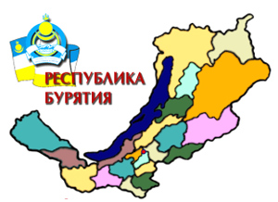
Exercise 1. Рассмотрите карту и ответьте на вопросы:
- What regions does Buryatia border on in the west (east, north, south)?
- What can you say about the relief of the republic? Are flora and fauna of the republic various?
- They say, the taiga is rich in fur-bearing animals, isn 't it?
- What are the most important rivers in Buryatia?
- Does the Selenga flow into the Baikal?
- What would you like to see in Buryatia?
Exercise 2. Почитайте текст и составьте план
The Buryat Republic was founded on the 30 th of May 1923. It occupies a great territory of Eastern Siberia to the east of Lake Baikal. The total area is about 351 300 square kilometres with the population of about one million people. The north- western borderline runs along the shore of Lake Baikal. It also borders on the Tuva Republic and the Mongolian Republic.
The Republic is mostly mountainous but there is hardly a place in Russia where such a variety of scenery can be found. There are mountains and boundless steppes, thick forests and quiet lakes, mountainous rivers and, of course, world famous Lake Baikal. A.P. Chekhov visited Buryatia on his way to Sakhalin. He was greatly impressed by the nature of Zabaikalye. In one of his letters he wrote "In Zabaikalye I saw the Caucasus, Switzerland, the valley of the river Don".
There are the Barguzin and the Hamar-Daban mountain ranges. But the most famous are the Sayans with its highest peak Munku-Sardyk (3491 metres).
The Buryat taiga is rich in fur - breading animals: bear, wolf, fox, squirrel, mink etc. Nature has smiled upon Buryatia, as it has a rich abundance of animal life, having such species like Barguzin sable and Baikal omul.
The Barguzin national park was established in 1913.
The rivers of Buryatia are of no great value as waterways. The longest of them are the Selenga, the Uda, the Barguzin and others. All of them flow into the Baikal and only the Selenga which is a major tributary of Lake Baikal is a navigable in summer and early autumn. The great part of the year the rivers are frozen. There is also a great number of small mountainous rivulets running into the Baikal with extremely pure water.
The most important mineral resources are ore, coal, asbestos, gold and graphite.
The climate is dry, winters are cold and the summers are hot. There are more than 300 sunny days in Buryatia. That’s why Buryatia is often called Sunny Buryatia.
Exercise 3 Ответьте на вопросы опираясь на текст
- Do you think the geographical position of the republic is good? Why?
- What can you say about the natural riches of the republic?
- What is Buryatia famous for?
Exercice 4. Решите кроссворд
Across
- The word we use for cedar, pine and fir trees.
- All the animals of an area.
- A thick coniferous forest in Siberia.
- An evergreen tree.
- A precious yellow metal.
- L and between hills or mountains often with a river flowing through it.
Down
- The mineral Gusinoozersk is rich in.
- A type of climate.
- All the plants of an area.
- A fur - bearing animal that can be found in Buryatia.
- A synonym of territory.
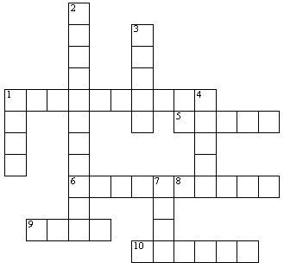

Part 2. LEGENDARY LAKE
Exercise 5. Read the text
One of the first to mention the Baikal was Marco Polo. The first of the Russians to cross it was the cossack Kurbut Ivanov. Some 300 years have passed since then and all these years the people have not only admired the gentle beauty of the Baikal, they have done their best to understand its mysteries.
But even today one cannot say, that we know all the secrets of this unique sheet of water. The Baikal is 25 million years old. And it still remains a young lake. It is 1634 meters deep. The Baikal is 636 km long, from 25 km to 79 km wide. Many seas are even considerably shallower. The lake consists 20 % of the world's fresh water supply.
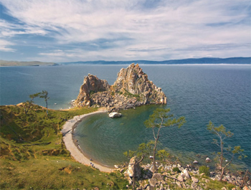
To Siberians it is a glorious sea. The water of the Baikal is amazingly clear, its transparency is 100 times greater tnan that of many other lakes, in fact it is legendary.
There one finds the Baikal seal, golomyanka and of course omul. The delicate fish has always been a favourite with Siberians. Even the thought of omul salted or smoked or baked is mouthwatering.
Many books have been written about the fauna of the Baikal. No wonder, there are 18900 different kinds of living creatures, big and small.
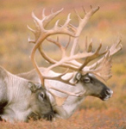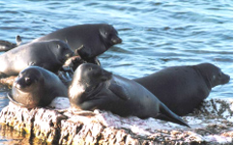
In the taiga around the Baikal you can see bear and deer, but the pride of the forest is the Barguzin sable, the only place in the whole world where it is found.
This is a story about the Baikal, the blue heart of Siberia.
Some years ago scientists raised the alarming question was the Baikal, whose water is the purest in the world, becoming polluted?
A special government commission has been set up to work out new, optimal and efficient measures for the protection of the lake. Lake Baikal and its shores have been declared as a specially protected zone of the country. Strict control is exercised over any economic activity around the lake. Now two scientific research ships explore the flora and the fauna of the lake.
Exercise 6. Now after you have read the text say new information you've learned.
- How old is Lake Baikal?
- Why do Siberians call the Baikal a sea?
- Do you like omul?
- Why is the Barguzin sable so famous all over the world?
- Have you been to the Baikal?
- What impressed you most of all?
- What makes the Baikal unique ?
Exercise 7. Read the song and learn it by heart:
BROTHER-LAKES
- Though we're from different lands.
But one the same goal unites us.
On the shores of the lakes we live
Brother - lakes the name to them we give.
Our lakes are far away from each other,
But our hearts are close to one another,
While hiking over the ancient cliffs
Baikal makes us great and close friends.
Refrain:
Oh, we must keep the lakes alive
Oh, we must keep the lakes to thrive
It's our sacred duty.
To keep for generations their beauty.
- We shall sail on Baikal waters
We shall sing a song of love
And the lake Baikal will surely hum
And nurse us as if in the cradle.
The only and cherished dream
Will help us keep Baikal clean
Protect the woods, the brooks, the flowers
And save the world itself at last.
- There always be the waters clean
There always be the shores in bloom
There will be no smoke in the sky
And the lake Baikal will never die.
Only a year will quickly fly
And near the Superior lake friends will meet again
We shall say our grandeur "Hi!"
To the friends, the lake and the sky.
Part 3. ULAN-UDE – THE CAPITAL
Exercise 8. Read the text. Which sightseeings would you show your foreign friends.
Ulan-Ude is the capital of Buryatia. It was founded in 1666 by Russian Cossacks. At present it is a big modern city 220 km east of Irkutsk with 360 000 people living in it. Verkhneudinsk (the old name of the city before 1934) was on the old Silk Road to the east and developed as a trading post in gold, silk and chinaware.
There are two rivers in the city: the Selenga and the Uda, which split a multitude of channels to form a number of picturesque green islands. The most famous one is Komsomolsk is -land. There are a lot of picnic places there.
The climate is healthy. But sometimes snowstorms complicate the life of the city in winter, particularly the transport and the heating system. Drinking water is good in the city.
Ulan-Ude is a cultural centre. It is famous for its theatres.
There are 5 higher establishments in the city:
- Buryat State University,
- East Siberian State Technological University,
- East Siberian State Academy of Culture and Arts,
- An Agricultural Academy and
- Research Institute.
Besides them there are medical and dance schools, creative unions of writers, painters, composers and journalists.
There are 3 districts in the city: Sovetsky, Oktyabrsky and Zheleznodorozhny.
Sovetsky district has become a business and cultural centre of the city. Zheleznodorozhny is a workers district. And Oktyabrsky is mainly a residential part of Ulan-Ude.
Soviet square is one of the finest open places in Ulan-Ude. It is the oldest centre of the city with its Opera and Ballet House, the movie theater "Progress", the building of the central post office and the hotels "Baikal" and "Buryatia".
A monument to the soldiers of the Second World War was opened with T-34 preserved as a reminder of the war. The main memorial is a place where newlyweds lay flowers on their wedding day. About 90000 people from Buryatia served in the war and 34 of them received the titel Hero of the Soviet Union. Streets and squares are named after them.
Ulan-Ude and its people are hospitable and friendly.
Exercise 9. Answer the questions. Suppose your foreign friends have come to the city for the first time.
- Where will you take them?
- What will you tell them about the most interesting sights in Ulan-Ude?
- What is the history of the city?
Ulan-Ude is an important cultural centre of the Republic. It is also a centre of education, isn't it? Prove it.
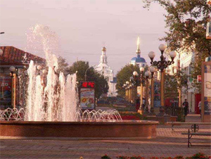
Exercise 10. Say whether the statements are correct.
- Ulan-Ude is mostly a residential city.
- There are not very many historic sights in Ulan-Ude.
- People take good care of the historic monuments of Ulan-Ude.
- The building of the Opera and Ballet House was designed by the Moscow sculptors brothers Nerodo.
Exercise 11. Take the pictures of different sights of Ulan-Ude and speak about the city's sights:
- Revolution Square
- Soviet Square
- the Opera and Ballet House
Exercise 12. Do you know the towns of Buryatia ?
- The second largest industrial centre in Buryatia is ...
- An important trading centre between Russia and China was ...
- This town was named after a well-known revolutionary.
- The town was built during the building of the famous Baikal-Amur Railway.
- A military and a trading centre where the Decembrists lived.
- This city is closely connected with the history of the Mongolian People 's Revolutionary Party.
- One of the biggest railway stations.
- The richest deposits of tungsten are near this town.
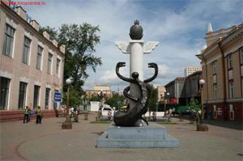
- This young town is slagged and sludged.
- The oldest museum in the republic is in this town. It was founded by the Academician Obruchev.
When was Ulan-Ude renamed?

