Выпишите названия овощей и приправ
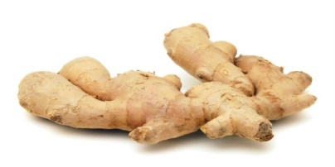
Vegetables (овощи)
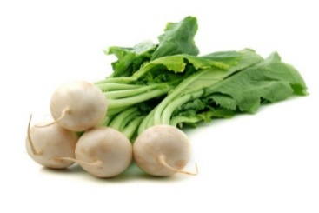
Potato [pəˈteɪtoʊ] - картофель
Tomato [təˈmeɪtoʊ] - помидор
Carrot [kærət] - морковь
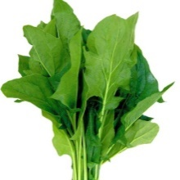
Cabbage [kæbɪdʒ] - капуста
Pepper [pepər] - перец
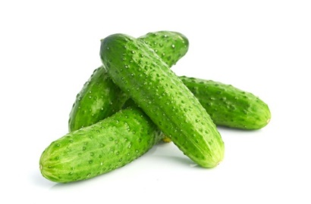
Hot / Chili pepper [hɑːt / tʃɪli pepər] - острый перец
Eggplant [eɡplænt] - баклажан
Cauliflower [kɔːliflaʊər] - цветная капуста
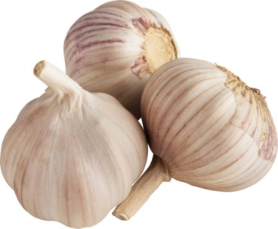
Onion [ʌnjən] - лук
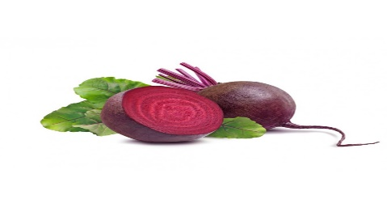
Garlic [ɡɑːrlɪk] - чеснок
Parsley [pɑːrsli] - петрушка
Celery [seləri] - сельдерей
Radish [ˈrædɪʃ] - редиска
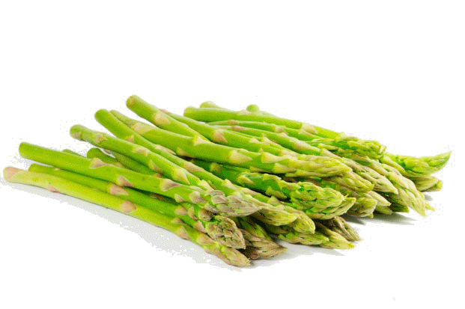
Cucumber [kjuːkʌmbər] - огурец
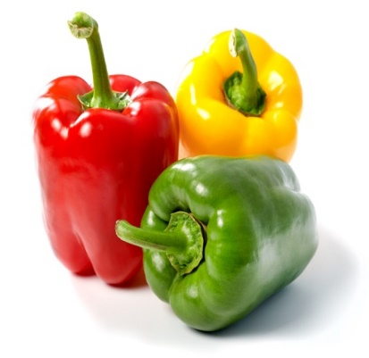
Lettuce [letɪs] - салат-латук
Pumpkin [pʌmpkɪn] - тыква
Courgette [kʊrˈʒet] - кабачок
Pea [piː] - горох
Chick pea [tʃɪk piː] - нут обыкновенный
Green beans [ɡriːn biːnz] - зеленая фасоль
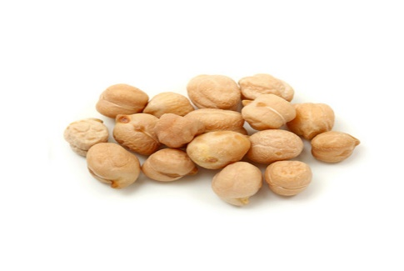
Asparagus [əˈspærəɡəs] - cпаржа
Green onion [ɡriːn ʌnjən] - зеленый лук, лук-перо
Broccoli [brɑːkəli] - капуста броколи
Spinach [spɪnɪtʃ] - шпинат
Corn [kɔːrn] - кукуруза
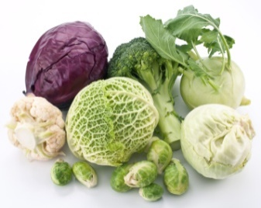
Yam [jæm] - батат, сладкий картофель
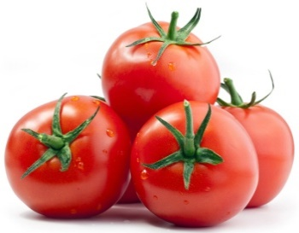
Beets [biːts] - свекла
Turnip [tɜːrnɪp] - репа
Ginger [dʒɪndʒər] – имбирь

Meat/poultry/fish (мясо/птица/рыба)
Meat/poultry
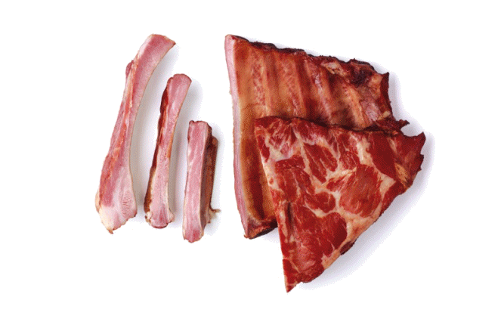
Mutton ['mʌt(ə)n]
Бекон Bacon ['beɪk(ə)n]
БифштексBeefsteak[ˈbiːfˈsteɪk]
БуженинаBoiled pork[bɔɪld pɔːk]
Ветчина, окорок Ham [hæm]
ГамбургерHamburger[ˈhæmbɜːgə]
Говядина Beef [bi:f]
Грудинка
Brisket[ˈbrɪskɪt]Дичь
Game[geɪm]Домашняя птица
Poultry ['pəultrɪ] Жареная курица
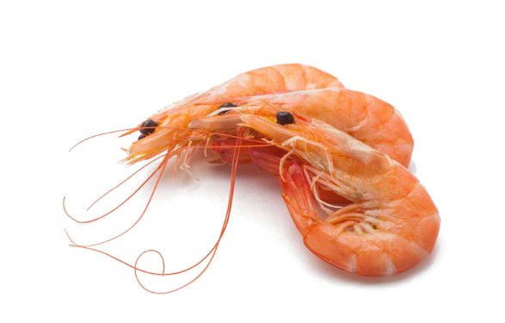
Roast chicken[rəʊst ˈʧɪkɪn]
ЗаливнойJellied[ˈdʒelid]
Индейка Turkey ['tɜːkɪ]
Колбаса Sausage ['sɔsɪʤ]
КотлетаCutlet[ˈkʌtlɪt]
КроликRabbit[ˈræbɪt]
Курица Chicken ['ʧɪkɪn]
Мясо Meat [mi:t]
ОбжаренныйRoasted
Chop[ʧɔp]
ПеченьLiver[ˈlɪvə]
РёбраRibs[rɪbz]
]Свинина Pork [pɔːk]
Сосиска Sausage [ə 'sɔsɪʤ]
СтуденьJelly[ˈʤelɪ]
Телятина Veal [vi:l]
Фарш Minced meat [mɪnst mi:t]
ФрикаделькаMeatball[ˈmiːtbɔːl]
ЯгнятинаLamb [læm]
)
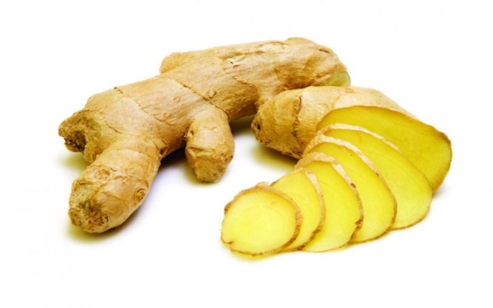
Bay [beɪ] - лавровый лист
Sage [seɪʤ]- шалфей
Bazil ['bæzl] – базилик
Oregano [ˌɔrɪ'gɑːnəu] - орегано (душица)
Mint [mɪnt] – мята
Parsley ['pɑːslɪ] – петрушка
Thyme [taɪm] – тмин
Rosemary ['rəuzm(ə)rɪ] – розмарин
Dill [dɪl] – укроп
Tarragon ['tærəgən] - тархун, полынь, эстрагон
Chives [ʧaɪv] - побеги зеленого лука
Cilantro [sɪ'lɑːntrəu] – кинза
Clove [kləuv] – гвоздика
Peppercorn ['pepəkɔːn] - горошины черного перца, анис
Cinnamon ['sɪnəmən] – корица
Cardamom ['kɑːdəməm] – кардамон
Nutmeg ['nʌtmeg] - мускатный орех
Ginger ['ʤɪnʤə] – имбирь
Saffron ['sæfrən] - шафран
Turmeric ['tɜːm(ə)rɪk] – куркума
Paprika ['pæprɪkə] – паприка
Coriander [ˌkɔrɪ'ændə] – кориандр
Cumin ['kjuːmɪn] - зерна кумина ( в России их еще называют зира, темьян)
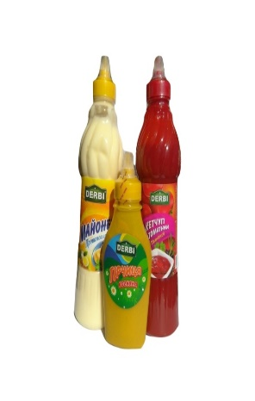
Salt [sɔːlt ] – соль
Sugar [ˈʃʊgə]– сахар
Vinegar [ˈvɪnɪgə]– уксус
Cinnamon [ˈsɪnəmən]– корица
Horseradish [ˈhɔːsˌrædɪʃ ] – хрен
Sauce [sɔːs ] – соус
Mayonnaise [ˌmeɪəˈneɪz] – майонез
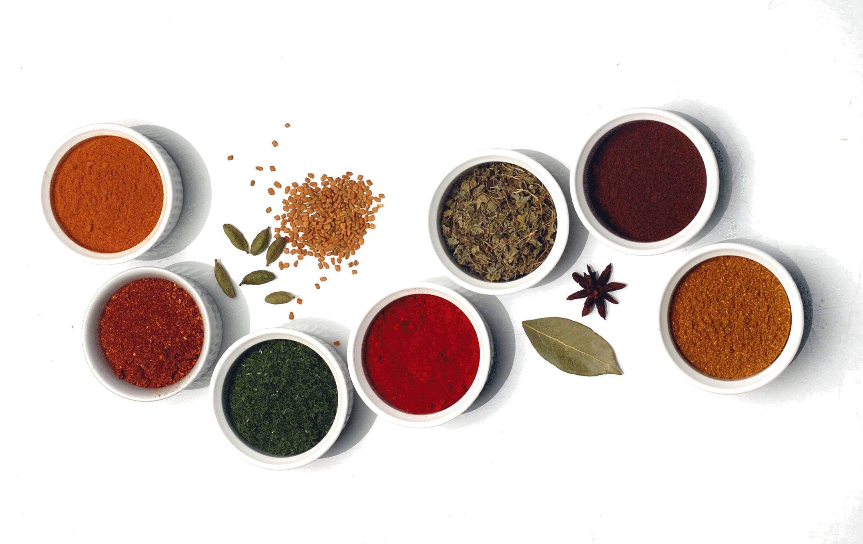
Mustard [ˈmʌstəd ] – горчица
Ketchup [ˈkɛʧəp] – кетчуп
Sour cream [ˈsaʊə kriːm] – сметана
Text Прочитайте текст выпишите названия супов .Напишите о своем любимом супе : название, ингредиенты, специи .
Russian cuisine is rich and varied. There is a big choice of appetizers, soups, hot and dessert dishes. Soup makes an important part of Russian meal. The traditional Russian soups are shchee, borsch, rassolnik, meat and fish solyanka, ukha, mushroom soup and soup in season – okroshka and cold beetroot soup. No two recipes are the same for borsch and shchee. Pelmeni is another specialty of Russian cookery. Nowadays there is a great number of recipes and verities of them. Russian cooking makes greater and more varied use of mushrooms than any other cuisine in the world. They are eaten raw, dressed with herbs, cooked into soups and pies, baked with cream. The other decoration of the Russian table is fish. It is serveв hot and cold, cold, in aspic or stuffed, fried, marinated and the like. And, of course, soft, pressed and red caviar is the hit of every festive table. The English ward “porridge” is no good for translating kasha, which covers almost all ways of cooking all grains in water, milk, stock and cream. The simplest and traditional way to serve Russian kasha is with plenty of good butter. There is also a large variety of milk products that are used in cooking. Such as granulated cream cheese tvorog, thick sour cream smetana and several types of sour-milk products of the yoghourt type. Russian cuisine is famouse for its pies, such as rasstegai, kulebyaka, vatrushki, krendeli, boubliki, baranki, sooshki, koolich. As for drinks, Russian cuisine offers you its original beverages: kvas and zbiten and a lot of different fruit and berry beverages.
Russian people are very hospitable and generous at the table. They invite everyone who enters their house to eat with them.
According to Russian tradition, a meal begins with the appetizers, for example a variety of salted, fermented and pickled cucumbers, cabbage and mushrooms, also soaked apples and cowberry to be followed by cold dishes. Also popular are soaked cranberry and marinated garlic. Vinaigrette, a Russian-style salad, is based on boiled beetroot diced. To this are added boiled carrots and potatoes, salted cucumbers, finely chopped onions and sauerkraut. The salad is dressed with mayonnaise or sunflower oil. Many Russian desserts are prepared with fruits and berries, for example, baked apples with vanilla and vodka sauce or apples baked with honey. Pancakes (blini) are a popular hot dish in Russia. They are made of wheat, buckwheat or millet and served with black and red caviar, cream butter, lightly-salted fish and sour cream. Pancakes come not only as appetizers but also as desserts with strawberries, jams or honey.

- Find the Russian equivalents to the following word combinations
Many types of cutting, with the head left on, was either French or French-trained, cut into strips, to make minced meat, in aspic, thick sour cream, yeast dough rolls, filled with curds, knot-shaped bread, water-fermented by yeast, a sign of respect, a typical trait of character.

- Find the English equivalents to the following words and word combinations.
Соленые, квашеные и маринованные огурцы; моченые яблоки; характерная черта; приправленный майонезом; мелко порезанный лук; сделать блюдо более красивым и ароматным; нежный вкус; чем больше слоев и ингредиентов, тем вкуснее блюдо.
Each family has a secret way of cooking rice soup. The rice makes the dish thick and hearty. In our recipe we offer the fastest and easiest version of cooking.

Soup recipe
In the Russian lexicon the word "soup" is present from the time of Peter the great. This simple dish takes its rightful place on our table. Soups are meat and vegetable, fish and even fruit. Mistress carefully select components to prepare based on the tastes of family members.
Soups with rice are popular in many countries. Rice turns the soup into a thick dish. From this it becomes very rich, but the extra calories are not added.

Ingredients:
- pork (400 grams);
- rice (0.5 cups);
- potatoes (4-5 pieces);
- carrots (Stuka);
- onion (1 piece);
- bell pepper (Stuka);
- tomato paste (10 grams or 1 tablespoon);
- vegetable oil;
- salt, pepper.

Method of preparation
In the pan you need to fry onions and carrots with vegetable oil. Coarsely chop the pork and also keep it in the pan for a few minutes.
Grind bell pepper strips and add it to the pan.
Pre-cook in boiling water until fully cooked potatoes and rice. Add the contents of the pan into a saucepan. There also add the tomato paste. If necessary, add water. Add salt and pepper to taste.
Cook for another 10 minutes. Cover with a lid and give the rice to the soup to infuse.
Bon appetit!

