Healthy Diet for Teenagers ( 10 Form)
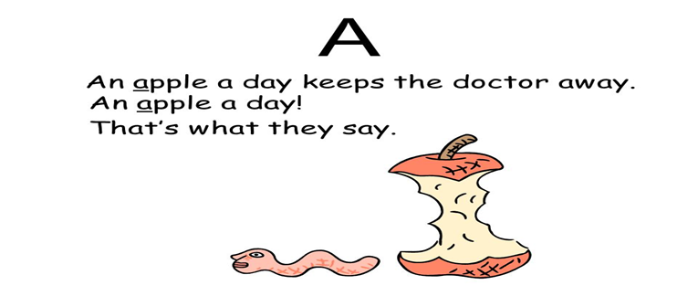
Looking for more information about healthy diet for teenagers? There's no question that today's teenagers are just about the busiest people on the planet!
Most teens pay very little attention to proper nutrition and a healthy diet.
What foods do teenagers choose first when they have to make quick choices? Hamburgers, French fries, fried chicken nuggets, and pizza.
All of those items are high in cholesterol, saturated fats, and carbohydrates. And to wash them down, teens reach for sugar-sweetened soft drinks or super-caffeinated beverages.
Nobody's saying it's easy for kids on the run to make good choices. Most of them skip breakfast, because both they and their parents have so little time in the morning.
And for lunch, the schools do a poor job of presenting menu choices that are both tasty and nutritional. Most kids choose French fries and ice cream over soggy vegetables and lean meat in a heartbeat-not realizing that those food choices are going to cost them heartbeats later in life.
Nutrition- питание, пища
cholesterol – холестерин
saturated fats [ˈsæʧəreɪtɪd fæt] -насыщенный жир
carbohydrates [ˈkɑːbəʊˈhaɪdreɪt-углеводы
beverages- газированные напитки
soggy vegetables- сырые овощи
lean meat – постное мясо
heartbeat- мгновения, сердечный ритм

№2 Overweight and Underweight Teenagers. What is In Common?
But these poor diets are not producing just overweight teens. Many teenagers, feeling the pressure from what they see on television shows and magazine ads, work hard to stay thin.
The problem is, while it's true that they cut back on what they eat, their food choices are still poor and do not resemble a healthy diet for teenagers.
If an adolescent satisfies her hunger at lunch time by dipping French fries into a milkshake, she might joke that she's getting a vegetable and milk. But what she's really consuming are fats, carbohydrates, and sugar.
As a result, we have both overweight and underweight teenagers -and both types are malnourished!
malnourished- истощенный
overweight - избыточный вес
underweight - недостаточный вес

+++++++++++++++++++++++++++++++++++++++++++++

№3 The Importance of Breakfast
One of general idea of a healthy diet for teenagers is that, kids need to realize the importance of breakfast. When there's no time for a quick bite in the morning, teens shrug it off as a way to save calories.
What they don't realize is that the body will sense that it's being starved, and it will cling to calories that it would otherwise burn.
The second thing is that studies have shown children who eat breakfast tend to do much better at school than their peers who go without. So skipping breakfast is not a diet shortcut.
The quality of breakfast is very important too. The biggest mistake that a parent can make is letting their kids eat sugary breakfast cereals.
These cereals are basically processed sugar with a few vitamins attached! That’s definitely no good, and results in a yo-yo of energy which gets the kids into bad habits of eating sugary snacks all day. However this can easily be counteracted by making a healthy breakfast every morning.

№4 Making the Right Food choices
Some of the best foods to include in a healthy diet for teenagers are:
High Protein Foods. Proteins help build your muscles and keep you from overeating as they make you feel full. Examples are lean white meat, fish, beans, eggs, yoghurt, nuts and seeds.
Lean Dairy Foods. These have calcium and Vitamin D which your body needs for building your bones. If you develop strong bones as a teenager, you will reduce the risk of getting diseases such as osteoporosis later in life. Good dairy foods are low fat milk, yoghurt and cheese.
Fruits and Vegetables. Have 2 servings of fruit and 5 of vegetables every day. Fruits and vegetables are packed with phytonutrients, vitamins, minerals and fibre and will keep your body in top condition mentally and physically.
Low Glycemic Load Carbohydrates. Carbohydrates are the energy source for your body, but the best carbohydrates are those that are broken down slowly into glucose, keeping blood sugar levels stable. Examples are whole grain breads and cereals, lentils and vegetables.
Healthy Fats. Your body needs fats to perform optimally, but you have to choose the right type of fats to eat. While saturated fats are bad, some fats are actually good for you, such as olive oil, nuts, seeds and oily fish. Include these in moderation in your daily diet to reduce long term risks for heart disease.
To successfully implement a healthy diet for teenagers, requires a change in eating patterns, and strategies to eat healthy.

