Упражнение 1 Посмотрите на фото. Прочитайте утверждения. Если утверждение верно, напишите в поле ответа слово True. Если утверждение ложно, напишите в поле ответа слово False.
Максимальное количество баллов: 3

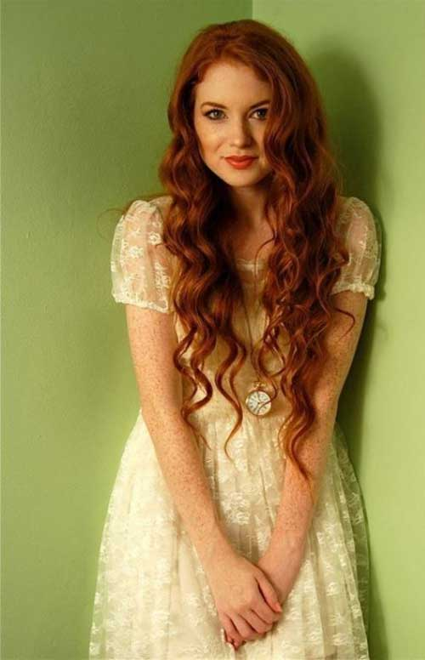
Утверждение | Ответ
She has long curly hair.
She is overweight.
She has a tanned face.

Упражнение 1.2 Посмотрите на фото. Прочитайте утверждения. Если утверждение верно, напишите в поле ответа слово True. Если утверждение ложно, напишите в поле ответа слово False.
Максимальное количество баллов: 3
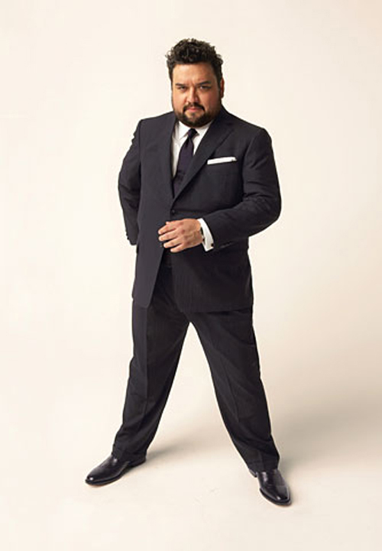
Утверждение | Ответ
He is a skinny man.
He has a round face.
He wears a short beard.

Упражнение 1.3 Перед Вами описание человека. Расставьте предложения в правильном порядке. Запишите последовательность цифр.
This is a young woman.
She has hazel eyes.
She has dark wavy hair.
I think, she is a fantastic woman.
She is slim.
Ответ: ______________________________________________

Упражнение 1.4 Перед Вами описание человека. Расставьте предложения в правильном порядке. Запишите последовательность цифр.
1) He has short hair.
I think, he is pleasant man.
He is plump.
This is a middle-aged man.
He has small eyes.
Ответ: ______________________________________________

Упражнение 1.5 Перед Вами описание человека. Расставьте предложения в правильном порядке. Запишите последовательность цифр.
He wears a short grey beard.
This is an old man.
He is tall and well-build.
I think, he is handsome.
He has short grey hair
2.1Упражнение прочтите и переведите.
Janet: I met your mother in the clothing shop yesterday.
Nancy: Is that so? What were you doing there?
Janet: I went to see if I could find a nice jacket. Something to go with my red dress.
Nancy: Did you see anything you liked?
Janet: Yes, but they didn’t have my size – only big sizes.
Nancy: Perhaps you could make it smaller?
Janet: I was thinking of that. I asked your mother, but she said it would be difficult. She said better wait until I found my own size, and I agreed with her.
Ответьте на вопросы
- Who went shopping yesterday?
- What did she shop for?
- What kind of shop did she go to?
- Did she find the thing?
- Did she buy it? If not, explain why?
- What was her friend advice?
- What did she decide to do, in the end?
2.2 Упражнение. Вставьте артикль, где нужно и переведите предложения.
Повторите тему «Артикль в английском языке» (для начинающих)
1. He’s looking for … plain shirt, but all shirts are striped.
2. I’m looking for … pair of … black pants.
3. She’s looking for … blouse.
4. I bought … new hat yesterday. … shop assistant said it suited me very well.
5. Where did you buy this overcoat? — I bought it at… big store in Oxford Street on … Tuesday.
6. My sister bought … blue hat on … Wednesday. … colour suits her very nicely as she has got … blue eyes.
7. I must buy … pair of … new gloves.
8. Where is … shoe department? — It is on … third floor.
9. I think … coat is a little tight. I don’t like … hat you have chosen. … colour is ut becoming to you.
10.I am going to give him … silk tie as … birthday present. He likes ties.

2.3Упражнение. Ответьте на вопросы (1-4).
- What clothes are fashionable nowadays?
- What do young people wear?
- Is there one fashion for everyone?
- Does age have anything to do with fashion and the clothes we wear?
Примите во внимание следующие детали:
1. style – стиль (casual, formal, fashionable, smart)
2. items of clothing – предметы одежды (jacket or jumper, trainers or slippers, skirt or trousers, shirt or T-shirt)
3. fabrics — ткань (made of cotton, wool, linen, silk, leather, lycra)
4. patterns — рисунок (plain, flowery, striped, checked)
5. colours – цвет
2.4 Упражнение. Прочтите мнения об одежде и моде. С чьей точкой зрения вы согласны
- highlight — подчеркивать
- features — черты
- offer — предлагать
- as a rule — как правило
- go camping — ходить в походы
- trend — тенденция (направление в моде)
- used to be — когда-то была
- go bankrupt — обанкротятся
- Opinion 1. People often wear very fashionable and expensive clothes but sometimes they can’t wear them well or wear the clothes which highlight their problems. To my mind, people should choose the clothes which are not fashionable, but which highlight their best features.
- Opinion 2. I don’t care what to wear as I don’t go out very often. As a rule, we spend evenings at home, sometimes we go camping at weekends. So, I don’t see any reason to wear fashionable clothes. I prefer to wear casual clothes because they are comfortable.
- Opinion 3. I believe that people who say they don’t care for fashionable clothes, usually simply don’t understand how to wear them. Or they don’t have enough money to follow the latest trends. As for me, I’d prefer to have trendy clothes than out-of-date ones.
- Opinion 4. To my mind, there is no fashion today. It used to be at the beginning of the 20-th century, when fashion houses offered new styles every decade. Nowadays fashion doesn’t offer anything new. Everything can be fashionable. I believe fashion houses will go bankrupt soon.

Задание 2. Выберите человека, который вам симпатичен, и опишите его, отвечая на вопросы (1-3).
- What does he/she look like?
- What personality does he/she have?
- Why do you like him/her?

