branch | [brɑːntʃ] | отвод
line |  | линия
value | [ˈvæljuː] | величина
voltage drop |  | падение напряжения
series | [ˈsɪəriːz] | последовательное
parallel | [ˈpærələl] | параллельное
main | [meɪn] | главный, основной
to use | [juːz] | использовать
in order (to) |  | для того чтобы

Series Circuit and Parallel Circuit
Compare circuits a and b. Circuit a consists of a voltage source and two resistors. The resistors are connected in series. Circuit a is a series circuit.
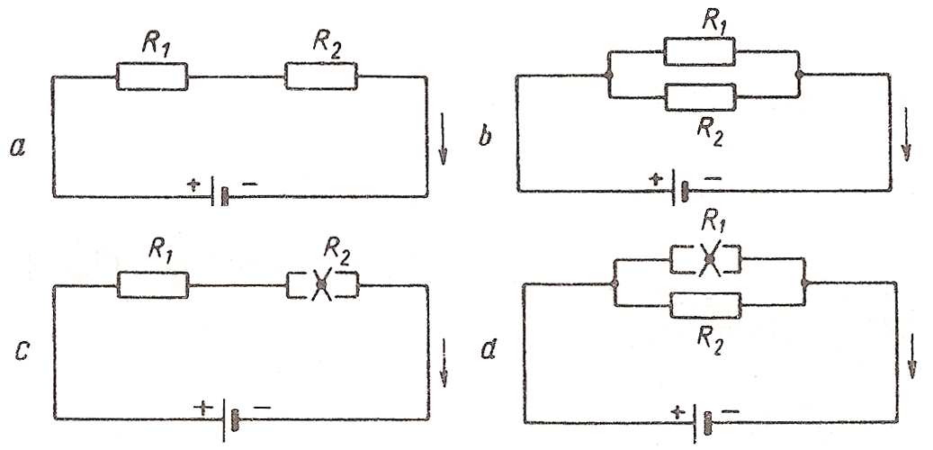
Fig. 2
Circuit b consists of a voltage source and two resistors. The resistors are connected in parallel. Circuit b is a parallel circuit.
A parallel circuit has the main line and parallel branches.
In circuit b the value of voltage in R₁ equals the value of voltage in R₂. The value of voltage is the same in all the elements of a parallel circuit while the value of current is different. A parallel circuit is used in order to have the same value of voltage.
In circuit a the value of current in R₁ equals the value of current in R₂. The value of current is the same in all the elements of a series circuit while the value of voltage is different. A series circuit is used in order to have the same value of current. In R₁, V₁ = I × R₁ is the voltage drop in R₁. In R₂ the voltage equals I × R₂; I × R₂ is the voltage drop in R₂. In circuit c a trouble in one element results in no current in the whole circuit. In circuit d a trouble in one branch results in no current in that branch only, a trouble in the main line results in no current in the whole circuit.

2. Complete these sentences using the correct variant:
1. A parallel circuit has | a) parallel branches only.  b) the main line and parallel branches.
2. A parallel circuit is used in order | a) to have the same value of current in all the elements.  b) to have the same value of voltage in all the elements.
3. In a parallel circuit a trouble in one branch | a) results in no current in that branch only.  b) results in no trouble in the whole circuit.
4. No current in a parallel circuit | a) results from a trouble in one branch.  b) results from a trouble in the main line.
5. The sum of IR voltage drops | a) equals the value of voltage in the circuit.  b) is less than the smallest voltage drop.  c) is more than the value of voltage in the circuit.

3. Complete the sentences using while. Follow the model:
Model: Resistors connected in series have the same value of current ... .
Resistors connected in series have the same value of current while resistors connected in parallel have the same value of voltage.
1. Resistors connected in series have different values of voltage while ... .
2. A trouble in one element of a series circuit results in no current in the whole circuit while ... .
3. In order to have the same value of current in all the elements, a series circuit is used while ... .
4. No current in a parallel circuit results from a trouble in the main line while ... .

4. Answer the following questions:
1. What type of circuit has the main line and parallel branches?
2. What type of circuit is used in order to have the same value of current in all the elements?
3. What type of circuit is used in order to have the same value of voltage in all the elements?
4. What does a trouble in the main line result in?
5. What does a trouble in a branch result in?
6. What does no current in a series circuit result from?
7. How much does the sum of IR voltage drops equal?
8. What is the difference between series and parallel circuits?

5. Draw and describe a series-parallel circuit.

Задание №1.
Read the text and answer the questions.
1. What are sources of on-board DC power?
2. What are sources of AC power?

AC/DC POWER SOUCES
AC Power Sources
The electrical network of the A 320/321 is normally supplied by two engine driven AC generators (IDG 1/2).
The drive unit (for constant speed) and the generator are integrated in one unit (Integrated Drive Generator; IDG).
Technical data:
Nominal power: 90 kVA
Nominal voltage: 115/200 V AC, three-phase
Nominal speed/frequency: 12000 rpm/ 400 Hz
The APU drives a third, auxiliary, generator (APU GEN) which can replace either main generator (GEN 1 and/or GEN 2).
The APU generator also serves as an independent AC power supply on ground.
Technical data:
Nominal power: 90 kVA
Nominal voltage: 115/200 V AC, three-phase
Nominal speed/frequency: 24000 rpm/ 400 Hz
In case of emergency configuration (loss of GEN 1,2 and APU) in flight, an AC generator driven by a hydraulic motor (CSM/G: Constant Speed Motor/Generator) supplies the systems required for aircraft control.
Technical data:
Nominal power: 5 kVA
Nominal voltage: 115/200 V AC, three-phase
Nominal speed/frequency: 12000 rpm/ 400 Hz
An external power receptacle, in front of the nose wheel well, enables to connect a ground power source to the electrical network during ground operation.
DC Power Source
The DC electrical system is normally supplied from the AC electrical system via Transformer Rectifiers.
Technical data:
Nominal current output: 200 A DC
Nominal voltage: In 115/200 V AC, three-phase Out 28 V DC
Two airborne nickel-cadmium batteries are installed.
The main functions of the batteries are:
- To start the APU in flight and on ground
- To supply the essential network in some configurations.
Technical data:
Nominal capacity: 23 Ah
Nominal voltage: 24 V DC
DC-AC Inverter
One static inverter of 1000 VA nominal power transforms the direct current voltage from battery 1 into a single phase 115 V, 400 Hz, alternating current.
The static inverter is automatically activated in the event of loss of all AC power sources and supplies the AC essential network.

Vocabulary:
1. generator |ˈdʒenəreɪtə| – генератор
2. constant speed drive |ˈkɔnstənt spi:d ˈdraiv| - привод постоянных оборотов
3. DC – direct current |diˈrekt ˈkʌrənt| – постоянный ток
4. AC – alternating current | ˈɔ:ltǝ:neitiŋ ˈkʌrənt|-переменный ток
5. APU - auxiliary power unit |ɔ: gˈziljəri ˈpauə ˈju:nit|– вспомогательная силовая установка (малый газотурбинный двигатель)
6. rectifier |ˈrektifaɪə| – выпрямитель (тока)
7. inverter |inˈvǝ: tə| – инвертор (тока)
8. receptacle |rɪˈseptəkl| - розетка

Power Sources
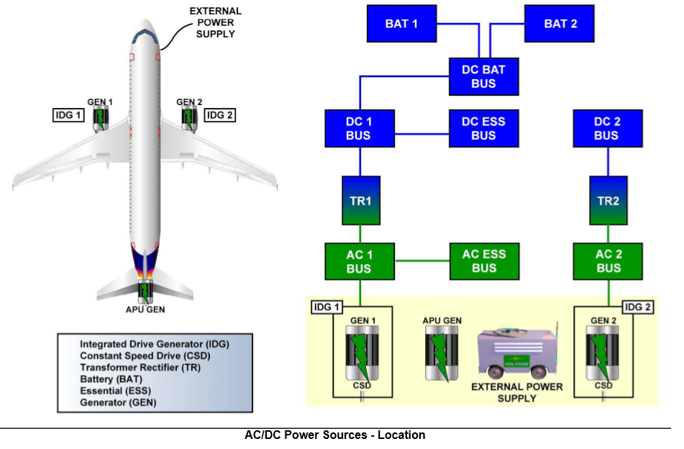

Пояснения к тексту и схеме:

1. Generator- a mechanically driven device for producing alternating current for airplane electrical system.
Генератор – механически проводимое в движение устройство для выработки переменного тока для электрической системы самолета.
2. Axillary power unit - a small turbine engine in the airplane for supplying electrical and pneumatic power for systems operation on the ground or in flight.
Вспомогательная силовая установка, малый газотурбинный двигатель на самолете для снабжения электрической и пневматической мощностями для работы системы на земле и в полете.
3. Battery - an electrical device for changing stored chemical energy into direct electric current.
Батарея (гальванический элемент) – электрическое устройство для превращения накопленной химической энергии в постоянный электрический ток.
4. Bus - a single wire or a group of wires which transfers power, data between several units or modules.
Шина - одиночный провод или группа проводов, которая проводит электрическую мощность, информацию между различными блоками и модулями.
5. Battery bus - an electrical conductor supplied with direct current from the battery or transformer – rectifier for power supply to operating components.
Шина батареи – электрический проводник, на который подается постоянный электрический ток от батареи или трансформатора – выпрямитель для подачи электрической мощности к работающим элементам.
6.Transformer rectifier - an electric device for changing alternating current to direct current to supply airplane electrical systems.
Блок трансформатора – выпрямителя – электрическое устройство для изменения переменного тока в постоянный, чтобы снабжать электрические системы самолета.

Задание 2.
Установите соответствие между английскими и русскими терминами и решите, какие позиции схемы «Power Sources» соответствуют каждому определению.
Английская спецификация:
1. generator
2. auxiliary power unit
3. battery
4. battery bus
5. transformer rectifier
Русская спецификация:
1. шина батареи
2. батарея
3. трансформатор – выпрямитель
4. вспомогательная силовая установка
5. генератор

Conversation.
Задание 3.
Read the text and answer the questions.

Abbreviations:
Kva – kilovott-ampere - киловольт-ампер
Rpm – revolutions per minute – оборотов в минуту
W – watt – ватт

alternating | [ˌɔːltəˈneɪtɪŋ] | переменный
diˈrect |  | прямой
diˈrection |  | направление
flow | [flou] | течение
necessary | [ˈnesɪsərɪ] | необходимый
to con'sider |  | рассматривать
use | [juːs] | использование

2. Read the words and write down their Russian equivalents:
[ˈsaɪkl] | cycle | ___________________________
[taɪp] | type | ___________________________
[pə ˈsekənd] | per second | ___________________________

3. Put down the Russian for:
one time | ____________ | direct voltage source | ____________
five times | ____________ | alternating voltage source | ____________
sixty times | ____________ | direction of flow | ____________

Types of Current
Current is a flow of electricity through a circuit. Let us consider two main types of current: direct and alternating. A direct current (d.c.) flows through a conducting circuit in one direction only. It flows provided a direct voltage source is applied to the circuit.
An alternating current (a.c.) is a current that changes its direction of flow through a circuit. It flows provided an alternating voltage source is applied to the circuit. Alternating current flows in cycles. The number of cycles per second is called the frequency of the current. In a 60-cycle alternating current circuit the current flows in one direction 60 times and in the other direction 60 times per second.
It is easy to transform a.c. power from one voltage to another by a transformer. Transformers are also used to step down the voltage at the receiving point of the line to the low values that are necessary for use.
When necessary a.c. can be changed into d.c. but this is seldom necessary.

4. Complete the sentences using the correct variant:
1. D.c. is a current that | a) changes its direction of flow.  b) flows in one direction.
2. A.c. flows provided | a) a direct voltage source is applied.  b) an alternating voltage source is applied.
3. In an alternating current circuit | a) current flows in one direction 60 times per second.  b) current flows in one direction 60 times and in the other direction 60 times per second.
4. A.c. | a) can be changed into d.c.  b) cannot be changed into d.c.

5. Complete these sentences using while. Follow the model on page 13.
1. An alternating current changes its direction of flow … .
2. A direct current flows provided a direct voltage source is applied … .

6. Answer the following questions:
1. What is current?
2. What types of current do you know?
3. When does a direct current flow?
4. What type of current is called an alternating current?
5. What type of current is called a direct current?
6. What is called the frequency of current?
7. What device is used to transform a.c. power from one voltage to another?
8. Is it often necessary to change a.c. into d.c.?

Topics for presentations:
1. Sources of on board DC power.
2. Sources of on board AC power.

