LEGENDARY LAKE
Упражнение 1 Прочитайте текст, переведите.
One of the first to mention the Baikal was Marco Polo. The first of the Russians to cross it was the cossack Kurbut Ivanov. Some 300 years have passed since then and all these years the people have not only admired the gentle beauty of the Baikal, they have done their best to understand its mysteries.
But even today one cannot say, that we know all the secrets of this unique sheet of water. The Baikal is 25 million years old. And it still remains a young lake. It is 1634 meters deep. The Baikal is 636 km long, from 25 km to 79 km wide. Many seas are even considerably shallower. The lake consists 20 % of the world's fresh water supply.
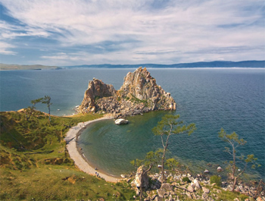
To Siberians it is a glorious sea. The water of the Baikal is amazingly clear, its transparency is 100 times greater tnan that of many other lakes, in fact it is legendary.
There one finds the Baikal seal, golomyanka and of course omul. The delicate fish has always been a favourite with Siberians. Even the thought of omul salted or smoked or baked is mouthwatering.
Many books have been written about the fauna of the Baikal. No wonder, there are 18900 different kinds of living creatures, big and small.
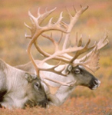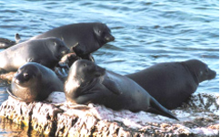
In the taiga around the Baikal you can see bear and deer, but the pride of the forest is the Barguzin sable, the only place in the whole world where it is found.
This is a story about the Baikal, the blue heart of Siberia.
Some years ago scientists raised the alarming question was the Baikal, whose water is the purest in the world, becoming polluted?
A special government commission has been set up to work out new, optimal and efficient measures for the protection of the lake. Lake Baikal and its shores have been declared as a specially protected zone of the country. Strict control is exercised over any economic activity around the lake. Now two scientific research ships explore the flora and the fauna of the lake.
Упражнение 2 Ответьте на вопросы письменно
- How old is Lake Baikal?
- Why do Siberians call the Baikal a sea?
- Do you like omul?
- Why is the Barguzin sable so famous all over the world?
- Have you been to the Baikal?
- What impressed you most of all?
- What makes the Baikal unique ?
Упражнение 3 В предложениях приведенных ниже найдите пропущенные слова , используйте текст
1 Lake Baikal and its shores have been declared as protected zone of the country
2 There one finds the Baikal seal and of course omul.
3 The water of the Baikal is clear, its transparency is 100 times than that of many other lakes, in fact it legendary.
4 The lake consists 20 % of the world's supply.

