Travelling
Артикли с географическими названиями
Прочитайте и выпишите примеры.

3.1. Study the usage of articles with geographical names.

Определенный артикль the употребляется с названиями стран, океанов, морей, заливов и др. географических названий, которые являются сочетаниями нарицательных существительных с определяющим словом:

the British Empire the United States
the Pacific Ocean the British Channel
the Mediterranean Sea the Baltic Sea
the Persian Gulf the Sahara Desert

Определенный артикль сохраняется перед названиями океанов и морей, даже когда слова Ocean и Sea опущены: the Pacific, the Atlantic, the Baltic

2. Когда географическое название представляет собой сочетание существительного собственного с предшествующим определяющим словом, то артикль не употребляется:

Eastern Europe, Central Asia, Northern Ireland

3.2. Study the usage of the definite article with geographical names.

Определенный артикль с географическими названиями употребляется в следующих
случаях:

С названиями некоторых стран, местностей и городов, особенно если они находятся во мн.числе: the Ukraine, the Crimea, the Caucasus, the Transvaal, the Congo, the Netherlands, the Argentine (Argentina), the Hague, the Philippines

Перед названиями рек: the Volga, the Thames

Перед названиями горных хребтов: the Alps, the Apennines

Запомни. Названия отдельных вершин употребляются без артикля: Everest

4. Перед названиями групп островов: the Canaries, the British Isles

5. С названиями замков, дворцов, зоопарков, станций и других мест и исторических зданий, если они не начинаются с названия города или фамилии человека: the White House

Сравни: Buckingham Palace, London Zoo, Westminster Abbey.

Если в географическом названии есть предлог of : the Republic of Ireland the Tower of London

Со словами, обозначающими стороны света: the east, the west, the north, the south, the middle (of) …: the north of Italy

Упражнение 1 .Допишите предложения о географических объектах.

_например.____Cairo_____is the capital of Egypt.
__The Atlantic__ is between Africa and America.
______________ is a country in northern Europe.
______________ is a river in South America.
______________ is the largest continent in the world.
______________ is the largest ocean.
______________ is a river in Europe.
______________ is a country in East Africa.
______________ is between Canada and Mexico.
______________ are mountains in South America.
______________ is the capital of Japan.
______________ are mountains in central Europe.
______________ is between Saudi Arabia and Africa.
______________ is an island in the Mediterranean.
______________ are a group of islands near Florida.
Alps
Amazon
Andes
Asia
Atlantic
Bahamas
Cairo
Kenya
Malta
Pacific
Red Sea
Rhine
Sweden
Tokyo
United States

Great Britain (text for beginners)
(after the textbook by Afanasjeva, V)
The United Kingdom of Great Britain and Northern Ireland (the UK) is the official name of the state, which is situated on the British Isles. This state is also called Great Britain after the main island with the same name. The UK consists of four countries, which are England, Scotland, Wales and Northern Ireland. Their capitals are London, Edinburgh, Cardiff and Belfast.
Эту информацию надо выучить выучить!

Geographical position of the UK. Географическое положение Соединенного королевства
The UK is an island state. The two main islands are Great Britain (where England, Scotland and Wales are situated) and Ireland (where Northern Ireland and the independent Irish Republic are situated). The two islands are separated by the Irish Sea. The UK is washed by the Atlantic Ocean in the north and the North Sea in the east.
The UK is separated from the continent by the English Channel and the Strait of Dover. The Strait of Dover is the narrowest part of English Channel. The nearest point to Europe is Dover which is only thirty-two miles from France. Dover is one of the most ancient ports. If you cross the English Channel by ferry you can see the white chalk cliffs of Dover and Dover Castle.
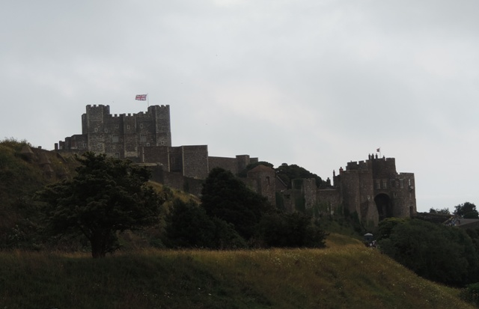

Dover Castle – Дуврский замок (фото автора)

Nationalities. Национальности
Everyone who was born in Britain is British. People from England are English. People from Scotland, Wales and Northern Ireland are not English. They are Scottish or the Scotts, Welsh and Irish.

Languages. Языки
Everyone in Britain speaks English. But in some parts of Scotland and Wales people speak different languages as well. The Welsh are especially proud of their language. They like to speak Welsh, to sing songs in Welsh and when you travel you can see road signs in Welsh all over Wales. Everyone in the UK speaks English but they all speak it differently. A Scottish person has to listen carefully if he wants to understand a Londoner or a Welsh person.
The Scottish people speak Gaelic [‘geɪlɪk] (гаэльский, язык шотландских кельтов).

Population. Население
More than 56 million people live in Britain. Many of them live in big industrial cities like London. The biggest cities of England are Manchester, Birmingham, Leeds, Liverpool (England); Edinburg, Glasgow, (Scotland).

Nature. Природа
Foreigners are often surprised by the fact that much of land in Britain is open country. There are many lonely hills, quiet rivers, deep lakes and just farmlands especially in the south of the country. The open country is named Lowlands but it changes for hills called Highlands in the north of the country.
Читать подробнее «The British Nature»
Climate. Климат
The climate in Great Britain is very mild. The winter temperature is between +3° and +7°. Snow does not cover the ground very long, except on the mountains. The summer temperature is between +15° and +18°. It often rains.
The English weather is very changeable. So when English people make plans for holidays they usually begin, “If the weather…”

State Symbol. Государственный символ
The flag of the United Kingdom is known as the Union Jack. It is made up of three crosses: the cross of St. George (the patron saint of England), the cross of St. Andrew (the patron saint of Scotland) and the cross of St. Patrick (the patron saint of Ireland).
Читать подробнее «The History of the British Flag»

Упражнения к тексту «Great Britain»
Упражнение 1. Read the text and complete the following sentences:
- … is the official name of the state which is situated on the British Isles.
- The capital of Great Britain is …
- The capital of Scotland is …
- The capital of Northern Ireland is …
- The capital of Wales is …
- Ireland and Great Britain are separated by …
- The UK is separated from the continent by …
- The UK is washed by… in the west.
- The UK is washed by … in the east.

Упражнение 2. Complete the following sentences making the right choice.
- The Union Jack is …
  - the flag of the UK
  - the flag of the USA
- English is spoken …
  - all over Britain
  - only in England
- The UK is the official name of the country situated …
  - on the island which is called Great Britain
  - on the British Isles
- Edinburgh is the capital of …
  - Wales
  - Scotland
- …
  - in Northern Ireland
  - on the smaller of the two biggest islands of the British Isles
- Great Britain and Ireland are separated by …
  - the North Sea
  - the Irish Sea
- The nearest point to Europe is …
  - the Strait of Dover
  - Dover
- The UK is washed by the Atlantic Ocean in …
  - the north
  - the west

