Based on 4D, ex.1
Read the text and complete the missing information in the diary.
John Carter comes from London. He is a second-year student at Exeter University. John has a regular daily routine. He wakes up at half past seven and, after a quick shower and breakfast, he catches the eight-fifteen bus to the university. Classes start at nine and finish at half past twelve. John has lunch in the students' club at a quarter to one and then he goes to the library to study for an hour. John loves to keep fit, so he meets his friends at the sports centre to play tennis at three o'clock. At five, he starts his part-time job at Nicole's Restaurant. He finishes work at eight and then has dinner in the restaurant kitchen. He gets back to his flat at eight the and studies for a couple or more hours. He usually goes to bed at eleven o'clock.

John's Diary
Monday, December 13
wake up | 7:30
catch bus | 1)
classes | 9:00-12:30
lunch | 2)
library | 1:30
play tennis | 3:00
work at restaurant | 3)  - 8:00
study | 8:30
go to bed | 4)
Put Y (yes) next to what you do and N (no) next to what you don't do as a part of your daily routine.
- wake up early
- go to school
- go to the gym
- have English lessons
- watch TV

- Now, look at Martha's diary and write about her daily routine in your copy-books.

- 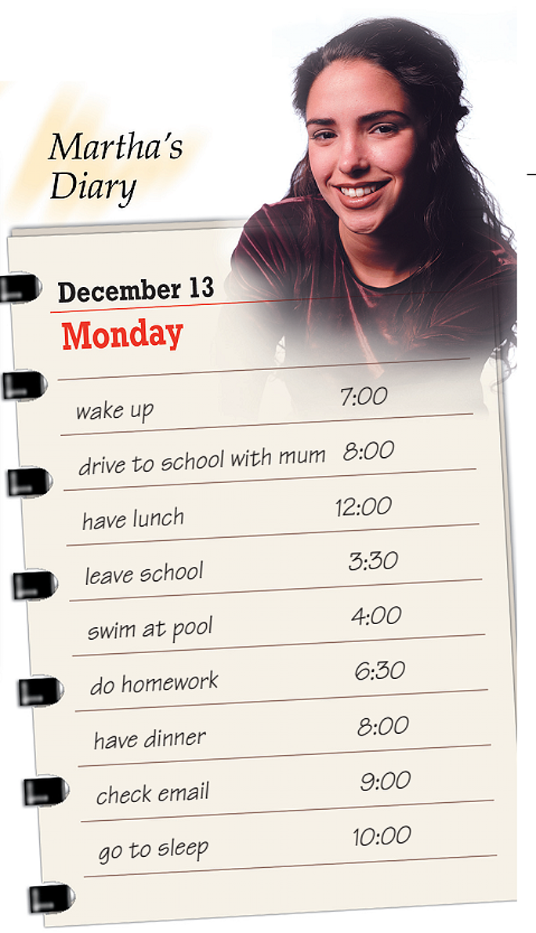
Put the verbs in the correct column.

- go
- spend
- study
- wash
- do
- walk
- begin
- try
- tidy
- play
- fly
- watch

-s | -es | -ies
 | goes

How often do you do the following? Make sentences about yourself in your copy-books. Use adverbs of frequency.
- am late for school
- tidy my room
- play cards with my friends
- wake up early
- cook
- go fishing
Например:
I am never late for school.

