Тема занятия Закон Ома

Цель : Познакомить с законом Ома.

Сделать конспект статьи,

скопировать схемы
,решить задачи
Task:1 Current equals 5 amp, resistance equals 10 ohms. How much is the voltage in the circuit?
Task: 2Resistance equals 80 ohm, voltage equals 55 volt. How much is the current in the circuit?
Task:3 Resistance equals 10.5 ohm, current equals 35 ampere. How much is the voltage in the circuit?
Task:4 Voltage equals 80.7 volt, current equals 120 ampere. How much is the resistance in the circuit?

Ohm’s Law and Resistance
Ohm’s law states that the voltage or potential difference between two points is directly proportional to the current or electricity passing through the resistance, and directly proportional to the resistance of the circuit. The formula for Ohm’s law is V=IR. This relationship between current, voltage, and relationship was discovered by German scientist Georg Simon Ohm. Let us learn more about Ohms Law, Resistance, and its applications.

Suggested Videos

Ohm's Law
Electric Resistance and Its Origin
Electricity and Electric Current

Ohm’s Law Definition
Most basic components of electricity are voltage, current, and resistance. Ohm’s law shows a simple relation between these three quantities. Ohm’s law states that the current through a conductor between two points is directly proportional to the voltage across the two points.
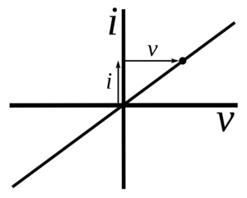

Ohm’s Law Formula
Voltage= Current× Resistance
V= I×R
V= voltage, I= current and R= resistance
The SI unit of resistance is ohms and is denoted by Ω
This law is one of the most basic laws of electricity. It helps to calculate the power, efficiency, current, voltage, and resistance of an element of an electrical circuit.

Browse more Topics under Electricity

Applications of Ohm’s Law
Ohm’s law helps us in determining either voltage, current or impedance or resistance of a linear electric circuit when the other two quantities are known to us. It also makes power calculation simpler.

How do we establish the current-voltage relationship?
In order to establish the current-voltage relationship, the ratio V / I remains constant for a given resistance, therefore a graph between the potential difference (V) and the current (I) must be a straight line.

How do we find the unknown values of resistance?
It is the constant ratio that gives the unknown values of resistance,
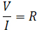
For a wire of uniform cross-section, the resistance depends on the length l and the area of cross-section A. It also depends on the temperature of the conductor. At a given temperature the resistance,
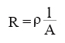
where ρ is the specific resistance or resistivity and is characteristic of the material of wire. The specific resistance or resistivity of the material of the wire is,
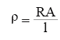
If ‘r’ is the radius of the wire, then the cross-sectional area, A = πr². Then the specific resistance or resistivity of the material of the wire is,
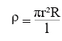

Limitations of ohms law
- Ohm’s law is not applicable to unilateral networks. Unilateral networks allow the current to flow in one direction. Such types of network consist elements like a diode, transistor, etc.
- Ohm’s law is also not applicable to non – linear elements. Non-linear elements are those which do not have current exactly proportional to the applied voltage that means the resistance value of those elements changes for different values of voltage and current. Examples of non – linear elements are the thyristor.
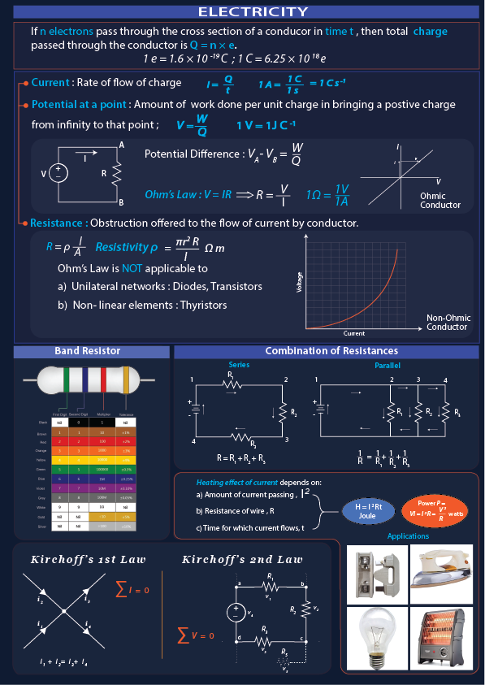

Resistors

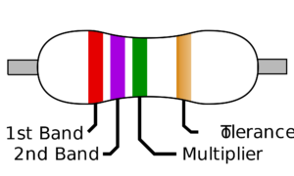
Resistors are one of the important blocks of electrical circuits. They are made up of the mixture of clay or carbon, so they are not only good conductors but good insulators too. Most of the resistors have four color bands. The first and second band reveal the first and second digits of the value respectively. The third band is used to multiply the value digits and the fourth band tells us the tolerance. If there is no fourth band, it is assumed that the tolerance is plus or minus 20%.

Resistance in series
A series generally means connected along a line, or in a row, or in an order. In electronics, series resistance means that the resistors are connected one after the other and that there is only one path for current to flow through.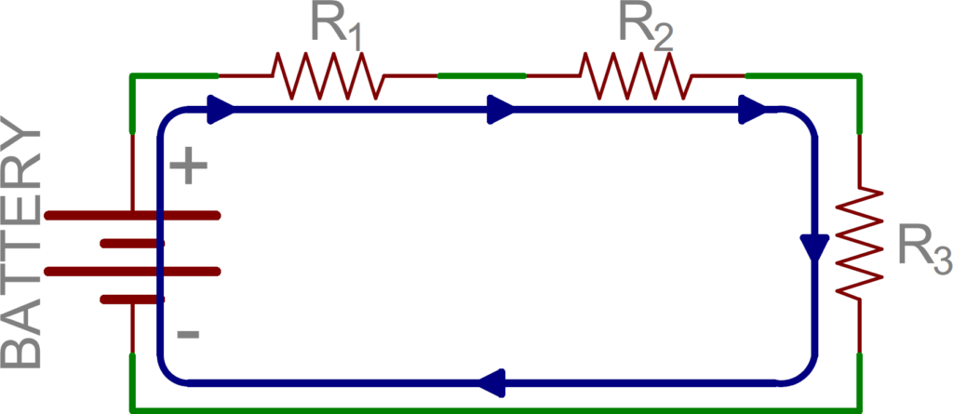
Source: SparkFun

Laws of Series Circuits
- Individual resistance add up to the total circuit resistance
- Current through the circuit is the same at every point.
- Individual voltages throughout the circuit add up to the total voltage.

Resistance in parallel
There are many different ways to organize a parallel circuit. In the practical world, most of the wiring is done in parallel so that the voltage to any one part of the network is the same as the voltage supplied to any other part of it.
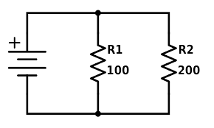

Laws of Parallel Circuits
- The reciprocals of all the individual resistances add up to the reciprocal of the total circuit resistance.
1/RT = 1/R1 + 1/R2 + 1/R3 …
- Voltage through the circuit is the same at every point.
- Individual current draws throughout the circuit add up to the total current draw.

Solved Example For You
Q. Find the resistance of an electrical circuit that has voltage supply of 10 Volts and current of 5mA.
Solution:
V = 10 V, I = 5 mA = 0.005 A
R = V / I
= 10 V / 0.005 A
= 2000 Ω = 2 kΩ

