3. Meters. (Unit 7)
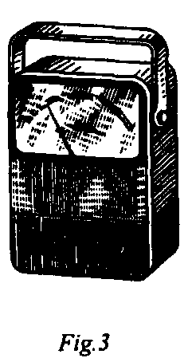
Among the most common meters used there are the ohmmeter, the ammeter and the voltmeter. The ohmmeter is used to measure the value of resistance. It consists of a milliammeter calibrated to read in ohms, a battery and resistors. The meter is connected in parallel and the circuit is not opened when its resistance is measured. The readings on the scale show the measured value.
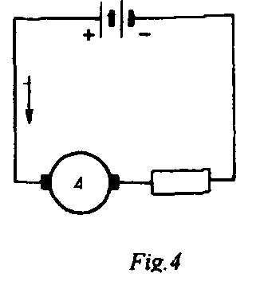
The ammeter is used to measure the value of current. When the ammeter is used the circuit should be opened at one point and the terminals of the meter should be connected to it. One should take into consideration that the positive terminal of the meter is connected to the positive terminal of the source the negative terminal - to the negative terminal of the source.
+The ammeter should be connected in series. The readings on the scale show the measured value.

Read the text
MEASUREMENTS OF ELECTRIC VALUES
The measurement of any physical quantity applies a determination of its magnitude in terms of some appropriate unit. In the case of simple fundamental quantities such as length, mass or time, the units themselves are simple.
Electrical and magnetic quantities are, however, much less simple than length, mass or time and cannot be measured directly by comparison with a material stand. The units in which these quantities are expressed have to be defined in terms of their observable affects obtained in experimental work, e.g. the weight of silver deposited in one second by a current when it is passed through a solution of silver nitrate is a measure of the magnitude of this current.
Electrical measurements can be classified broadly as neither absolute measurements, nor secondary measurements, but the first class of such measurements is rarely undertaken.
II. Guess the meaning of the following international words:
1) physical; 2) system; 3) fundamental; 4) material; 5) experimental; 6) absolute; 7) class.
III. Give the English equivalents to the words below:
1) измерение; 2) определение; 3) соответствующая единица; 4) быть соответствующим; 5) сравнение; 6) достигать; 7) серебро; 8) широко; 9) заботиться; 10) длина.
IV. Translate into Russian the words and expressions from the text:
1) magnitude; 2) electrical and magnetic quantities; 3) to define; 4) observable affects; 5) to deposit; 6) secondary measurements; 7) to undertake.
V. Insert the words:
1. Magnitude of any … (физическая величина) must be determined in terms of some appropriate … (единица).
2. … (единицы) are simple for simple … (основных) quantities.
3. … (электрические) and (магнитные) quantities cannot be measured simply.
4. These units must be … (определены) in terms of their … (наблюдаемые) effects obtained in… (экспериментальная работа).
5. Absolute … (измерения) are … (редко) undertaken.
VI. Answer the questions:
1. What do we need to measure any physical quantity?
2. What simple units for measuring of simple fundamental quantities do you know?
3. Can electrical and magnetic quantities be measured directly by comparison with a material stand?
4. How can we get units for defining electrical and magnetic quantities?
5. What types of measurement do you know?
VII. State questions to the underlined words:
1. Before we can measure, we must decide upon a system of units.
2. Electric and magnetic quantities are much less simple than fundamental quantities.
3. These quantities cannot be measured directly by comparison with a material stand.
4. Electrical measurements can be classified as neither absolute, nor secondary measurements. (Question-tag)
VIII. Topics for discussion:
1. Measurement of any physical quantity;
2. Measurement of electric and magnetic quantities.
I. Read the text
ELECTRICAL MEASURING INSTRUMENTS AND UNITS
Any instrument which measures electrical values is called a meter. An ammeter measures the current in amperes. The abbreviation for the ampere is amp. A voltmeter measures the voltage and the potential difference in volts.
The current in a conductor is determined by two things – the voltage across the conductor and the resistance of the conductor. The unit by which resistance is measured is called the ohm. The resistance in practice is measured with the ohm-meter. A wattmeter measures electrical power in watts. Very delicate ammeters are often used for measuring very small currents. A meter whose scale is calibrated to read a thousandth of an ampere is called a micro ammeter or galvanometer.
Whenever an ammeter or voltmeter is connected to a circuit to measure electric current or potential difference, the ammeter must be connected in series and the voltmeter in parallel. To prevent a change in the electric current when making such an insertion, all ammeters must have a low resistance. Hence, most ammeters have a low resistance wire, called a shunt, connected across the armature coil.
A voltmeter, on the other hand, is connected across that part of the circuit for which a measurement of the potential difference is required. In order that the connection of the voltmeter to the circuit does not change tire electric current in the circuit, the voltmeter must have high resistance. If the armature coil does not have large resistance of its own, additional resistance is added in series.
The heating effect, electrostatic effect, magnetic and electromagnetic effects of electric current are used in order to produce the defleting torque. The resulting measuring instruments are called: (a) hot wire, (b) electrostatic, (c) moving iron, (d) moving coil, and (e) induction. Various types are used with both d. c. and a. c., but the permanent-magnet moving coil instrument are used only with d. c., and the induction type instruments are limited to a. c.
All, except the electrostatic type instruments, are current measuring devices, fundamentally ammeters. Consequently, most voltmeters are ammeters designed also to measure small values of current directly proportional to voltage to be measured.
II. Guess the meaning of international words:
1) instrument; 2) fact; 3) abbreviation; 4) voltmeter; 5) ohm; 6) ohmmeter; 7) wattmeter; 8) galvanometer; 9) shunt.
III. Give the Russian equivalents to the words below:
1) resistance; 2) to offer; 3) scale; 4) to prevent; 5) armature; 6) connection; 7) heating effect.
IV. Give the English equivalents to the words and word-combinations:
1) амперметр; 2) разница потенциалов; 3) определят; 4) чувствительный; 5) градуировать; 6) вставка; 7) катушка; 8) переменный ток (второй термин).
V. Answer the questions:
1. How are electrical values measuring instruments called?
2. How must the ammeter and the voltmeter be connected?
3. What resistance must the ammeter and the voltmeter have?
4. What resulting measuring instruments do you know?
5. What types of instruments are used with both d. c. and a. c.?
6. What instruments are used only with d. c. and limited to a. c.?
VI. Make up sentences corresponding to the contents of the text:
1. A meter the potential difference in volts
2. An ammeter the resistance
3. An ohmmeter measures very small currents
4. A voltmeter electrical values
5. A galvanometer the current
1. The voltage in ohms
2. The current is measured in volts
3. The resistance in amperes
VII. Describe different types of measuring instruments and units, using the table in Task V

