Запишите таблицу в тетрадь

The Political System of the UK, the USA, Russia

(сравнительная таблица)
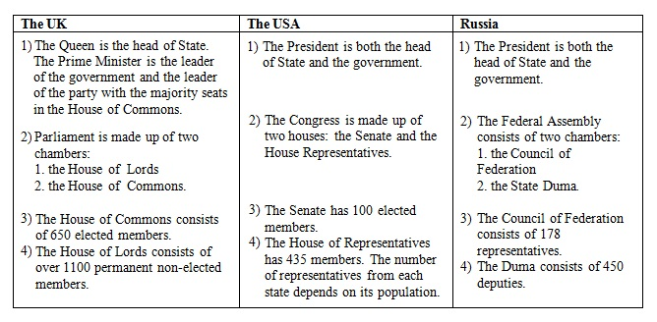
* * *

Переведите текст и ответьте на вопросы

Information to know about the Political System of the UK
- The legislative power belongs to Parliament. It makes laws.
- The House of Commons is more powerful: it decides national policy.
- The House of Lords has little political importance.
- The executive power belongs to the Government. It executes laws (puts them into effect.)
- Real power in the UK belongs to Parliament and the Government.
- The term “constitutional monarchy” means that GB is governed by Parliament, and the monarch is Head of State.
- The Queen has very little power. She has to put her signature on new laws even if she doesn’t like them.
- Her most important function is ceremonial. The Queen is a symbol of Britain’s long history and tradition. On great occasions she is driven through the streets in a golden carriage, guarded by soldiers.
- She represents Britain when she meets other heads of state. Every autumn she opens the Parliament. Every year she speaks on TV on Christmas day. She opens new hospitals, theatres and museums. After disasters she send messages to the families of the victims.
- The Queen of GB is also the Head of Commonwealth and also the Queen of Canada, Australia, New Zealand, etc. The Commonwealth is an association of former members of British Empire (British colonies) and Britain, which was formed in 1949.
Questions:
- What functions has Parliament ?
- What function has the Government?
- What does the Queen do?
- What does the term constitutional monarchy means?

