Упражнение 1. Опишите людей на картинке.
Пример: She’s tall and slim. She’s got a lovely figure.- Она высокая и стройная. У нее красивая фигура.
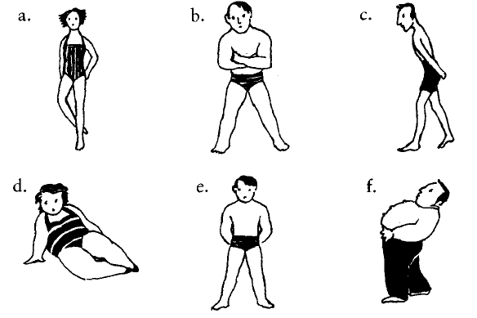
Упражнение 2. Поставьте в предложения следующие словосочетания:
long nails
big feet
lovely complexion
hairy chest
bad skin
deep voice
long legs
thin legs
Переведите полученные предложения.
1. Size 12! Are these your shoes? You’ve got _______ , haven’t you?
2. You’ve got such _______ . Would you like to move the seat back a bit?
3. I’ve never seen you in shorts before. You’ve got such _______ . You should go running and try to build up them up a bit!
4. My boyfriend’s got a really _______ . It’s like being with a gorilla.
5. You’ve got such lovely _______ . Are they real?
6. He’s got such a _______ . I find it very sexy when he speaks to me on the phone.
7. Keith’s new girlfriend must spend a fortune on face cream to have such a _______ .
8. Poor Tim. He’s had really _______ since he was 13.
Упражнение 3.
Вместо пропусков поставьте данные в скобках слова., напишите перевод.
1. He’s a _______ , _______ man with _______ , _______ hair.
(short, tall, fair, good-looking)
2. She’s a _______ , _______ woman with _______ hair.
(tall, long, thin)
3. I’ve got _______ , _______ hair and I’m tall and very _______ .
(thin, straight, black)
4. She’s very _______ with a _______ tan and _______ _______ hair.
(blonde, lovely, good-looking, long)
5. I wouldn’t describe my husband as _______ , _______ and _______ ! Short, overweight, and going thin on top is more accurate!
(handsome, dark, tall)

