Спишите словарные слова. Прочитайте тексты. Переведите один из текстов. Перенесите таблицу о политических системах в тетрадь.

The Political System of the UK, the USA, Russia

(сравнительная таблица)
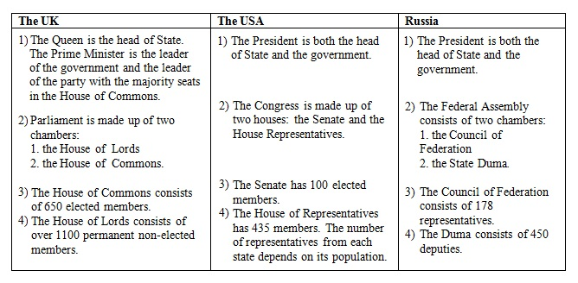

The Political System of the UK
Из этой статьи вы узнаете от политическом устройстве Соединенного королевства (the political system of the UK of Great Britain and Northern Ireland). Прежде чем читать эту статью, выучите список английских слов по теме The Political System of Different Countires.
ЗАПОМНИТЕ
- The UK is a constitutional monarchy and a parliamentary democracy.
- The monarch is the head of the state (Queen Elizabeth the Second)
She doesn’t rule the country, has ceremonial function; signs bills.
- The prime-minister is the head of the government.
He is the leader of the party with the majority seats in the House of Commons.
- Parliament consists of two chambers or houses:
the House of Lords
the House of Commons
The House of Lords consists of 651 MPs (elected). It makes laws.
The House of Commons consists of 1203 non-elected peers. It can delay bills and ask for rewriting certain parts.
- The head of the both Houses of Parliament is the Queen. She is also the head of the executive branch.
Mind the articles:
- the Houses of Parliament
- the House of Lords
- the House of Commons
- the government
- But__ Parliament
* * *

Information to know about the Political System of the UK
- The legislative power belongs to Parliament. It makes laws.
- The House of Commons is more powerful: it decides national policy.
- The House of Lords has little political importance.
- The executive power belongs to the Government. It executes laws (puts them into effect.)
- Real power in the UK belongs to Parliament and the Government.
- The term “constitutional monarchy” means that GB is governed by Parliament, and the monarch is Head of State.
- The Queen has very little power. She has to put her signature on new laws even if she doesn’t like them.
- Her most important function is ceremonial. The Queen is a symbol of Britain’s long history and tradition. On great occasions she is driven through the streets in a golden carriage, guarded by soldiers.
- She represents Britain when she meets other heads of state. Every autumn she opens the Parliament. Every year she speaks on TV on Christmas day. She opens new hospitals, theatres and museums. After disasters she send messages to the families of the victims.
- The Queen of GB is also the Head of Commonwealth and also the Queen of Canada, Australia, New Zealand, etc. The Commonwealth is an association of former members of British Empire (British colonies) and Britain, which was formed in 1949.

The Political System of the USA
Из этой статьи вы узнаете о политическом устройстве Соединенных Штатов Америки (the political system of the USA). Прежде чем читать эту статью, изучите английские слова по теме «The Political System of Different Countires».
Кстати, политическая система в США такая же как в России, а именно федеративная республика.
Слова федеративная, президентская и парламентская являются синонимами.
The USA is a federal (presidential, parliamentary) republic.
Mind the articles & the stress in the words:
- the Senate [‘senɪt] — Сенат
- the House of Representatives [ˌreprɪ’zentətɪv] — Палата представителей
- the Capitol [‘kæpɪt(ə)l] — Капитолий
- the White House – Белый дом
- the Supreme Court [s(j)uː’priːm] — Верховный суд
- But__ Congress — Конгресс

The Political System of the USA (основная информация)
- The president is the head of state.
- The head of state in the USA (the president) has the real power. For example, he is Commander-in- Chief of the armed forces (Главнокомандующий ВС), he makes treaties (ведет переговоры) and appoints ambassadors (назначает послов), can veto laws.
- Congress and the Supreme Court control the president’s power.
- The legislative power in the USA belongs to Congress, consisting of the Senate [`senit] and the House of Representatives (two senators for each state (100 in total).
- The executive power belongs to the President, the Vice-President and the Cabinet.
- The President, the Head of the executive branch, is elected for a four-year term.
- In the USA each state has its own constitution (50 states and the District of Columbia).
- The American Bill of Rights, passed in 1791, forms the first ten amendments to the Constitution of the USA.
- Congress sits in the Capitol.
- The White House is the president’s residence.
- There are two main political parties in the USA: the Democratic and the Republican.

The Political System of Russia (основная информация, )
Из этой статьи вы узнаете о политическом устройстве России (the political system of Russia). Прежде чем читать эту статью, изучите английские слова по теме «The Political System of Different Countires».
Кстати, политическая система в России такая же как и в США, а именно федеративная республика. Слова федеративная, президентская и парламентская являются синонимами.
Читайте в этой статье:
- The Political System of Russia
- Тест. The Political System of Russia

The Political System of the Russian Federation
The official name of Russia is the Republic of Russian Federation.
The Russian Federation is a federal (presidential, parliamentary) republic.
Mind the articles:
- The Federal Assembly – Федеральная Собрание (the Russian Parliament)
- The Council of Federation – Совет Федерации
- The State Duma – Государственная Дума
- The Council of Ministers = The Cabinet of Ministers – Совет министров (правительство)
- The Chairman of government= The Prime Minister – Председатель правительства
- The Supreme Court – Верховный суд
- The Constitutional Court – Конституционный суд
The Constitutional Court can declare actions of the president or government unconstitutional.
* * *

The Political System of Russia (основная информация)
- The president is the head of the state. He has much power: can dissolve the Duma, can veto laws.
- The National Government of Russia consists of the President, the Council of Ministers and the Federal Assembly.
- The legislative power in Russia belongs to the Federal Assembly. It consists of two houses or chambers: the Upper House (the Council of Federation) and the lower House (the State Duma).
- The Duma consists of 450 deputies.
- The executive power belongs to the government, e.g. to the Cabinet of Ministers, headed by the Prime-Minister.
- The head of government is the Prime Minister.
- The President is the Head of the executive branch. He is elected for a four-year term

