Food and drinks exercises.
Упражнения идут от простых к более сложным.
Упражнение 1. Распределите названия продуктов по следующим категориям. Цифра обозначает количество слов в категории.
Chocolate, potato, tea, steak, pear, carrot, garlic, cake, pineapple, broccoli, wine, water, peach, coffee, ice cream, tomato, ham, watermelon, cookies
MEAT (2):
DRINKS (4):
DESSERTS (4):
FRUIT (4):
VEGETABLES (5):
Упражнение 2. Look at the picture and say true or false.
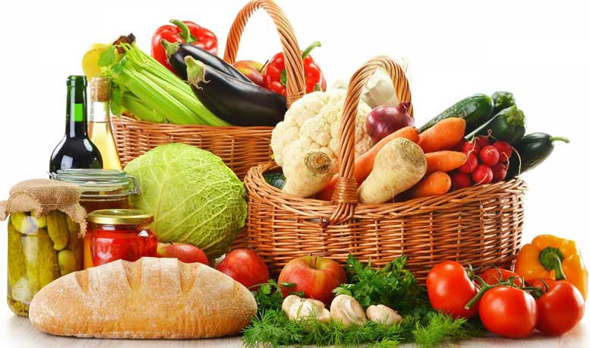
- THERE IS SOME COFFEE
- THERE ARE SOME TOMATOES
- THERE ISN’T ANY MILK
- THERE IS SOME TEA
- THERE AREN’T ANY EGGS
- THERE ARE SOME COOKIES
- THERE IS SOME BACON
- THERE IS SOME BREAD
- THERE ARE SOME MUSHROOMS
- THERE ARE SOME PANCAKES
- THERE IS A CABBAGE
- THERE ARE SOME APPLES
Упражнение 3. Назовите продукт по описанию.
- You need me to make a sandwich or toast. – B_________
- I’m yellow or white. I’m made from milk. People like me on their pizza. — C___________
- People eat us fried, boiled or scrambled. — E_______
- I’m a very popular fast food with a sausage in the middle. — H______________
- I’m a long yellow fruit. — B_____________
- Rabbits love this orange vegetable. – C_______________
Упражнение 4. Ответьте на вопросы.
- How often do you drink milk?
- How often do you eat at restaurants?
- What’s your favorite food?
- What food do you hate?
- What’s your favorite ice-cream flavor?
- What’s the strangest thing you’ve ever eaten?
- Are you allergic to any food?
- What’s your favorite drink?
Упражнение 5.
- Name 5 fruits.
- Name 5 vegetables.
- Name 5 drinks.
- Name 3 sweet foods.
- Name 3 salty foods.
- Name 3 bitter foods.

