1. Спишите слова и выражения
meter | [ˈmiːtə] | измерительный прибор
battery | [ˈbætərɪ] | батарея
scale | [skeɪl] | шкала
readings |  | показания на шкале (прибора)
terminal | [ˈtəːmɪnl] | клемма
positive | [ˈpɔzɪtɪv] | положительный
negative | [ˈneɡətɪv] | отрицательный
to measure | [ˈmɛʒə] | измерять
to take into consideration |  | принимать во внимание
in this way | [weɪ] | таким путем, таким образом

Переведите текст

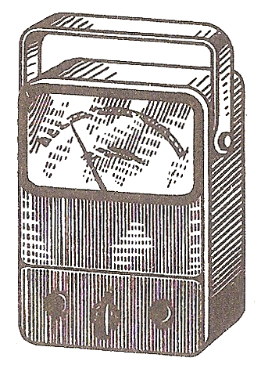
Meters
Fig. 3
Among the most common meters used there are the ohmmeter, the ammeter and the voltmeter. The ohmmeter is used to measure the value of resistance. It consists of a milliammeter calibrated to read in ohms, a battery and resistors. The meter is connected in parallel and the circuit is not opened when its resistance is measured. The readings on the scale show the measured value.
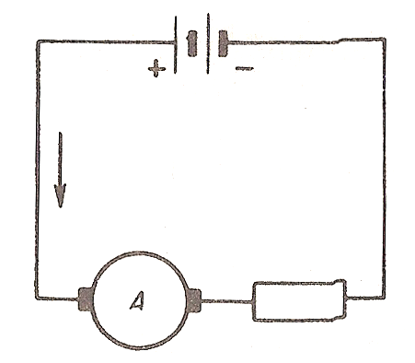
The ammeter is used to measure the value of current. When the ammeter is used the circuit should be opened at one point and the terminals of the meter should be connected to it. One should take into consideration that the positive terminal of the meter is connected to the positive terminal of the source; the negative terminal − to the negative terminal of the source.
The ammeter should be connected in series. The readings on the scale show the measured value.
Fig. 4

3. Напишите предложения закончив их одним из предложенных вариантов
1. The ammeter is | a) a common meter.  b) an uncommon meter.
2. In order to measure the value of current | a) the ohmmeter is used,  b) the voltmeter is used.  c) the ammeter is used.
3. A meter has | a) positive terminals only.  b) negative terminals only.  c) positive and negative terminals.
4. When the ammeter is used | a) the circuit should be opened.  b) the circuit should not be opened.
5. The ammeter should be connected | a) in series.  b) in parallel.
6. One should take into consideration that | a) the positive terminal should be connected to the negative terminal.  b) the positive terminal should be connected to the positive terminal of the source.

5. Ответьте на вопросы
1. What is the ammeter used for?
2. What is the voltmeter used for?
3. What is the ohmmeter used for?
4. What terminals does a meter have?
5. Should the measured circuit be opened when the voltmeter is used?
6. Should the measured circuit be opened when the ammeter is used?
7. In what way should the voltmeter be connected to the circuit?
8. In what way should the ammeter be connected to the circuit?
9. What is the difference between a voltmeter and an ammeter?
10. What common meters are used to measure the values in a circuit?

6. решите задачи
1. Suppose the ammeter scale reads 1.9 amp, the voltmeter scale reads 2.4 V; how much is the value of resistance in the measured circuit?
2. Suppose the ohmmeter scale reads 75 ohms, the voltmeter scale reads 220 V; how much is the value of current in the measured circuit?
3. Suppose that you have a series circuit consisting of three resistors and a voltage source. R₁ = 0.18 ohm, R₂ = 1.15 ohms, R₃ = 2 ohms, I = 10 amp. Find the voltage drop across each resistor; find the value of voltage in the circuit. Suppose R₁ gets open. What does it result in?
4. Two resistors are connected in series. R₁ = 7,000, R₂ = 2,200, I = 110 amp. Find the voltage drop across each resistor. Suppose no current passes through the circuit, what does it result from?

