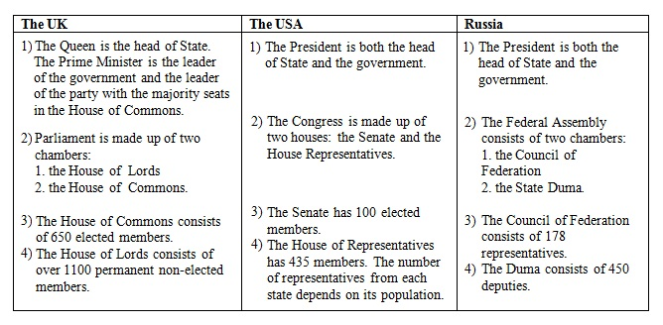

Задание № 1

Найдите в правой колонке русские эквиваленты английских слов и словосочетаний:

1. Parliament a) судебная власть
2. The House of Lords b) исполнительная власть
3. Head of state c) законодательная власть
4. Prime Minister d) избирать, выбирать
5. Power e) парламент
6. Government f) победить, выиграть
7. General election g) назначать
8. To elect h) Палата Общин
9. To consist of i) Палата Лордов
10. To appoint j) правительство
11. To win k) состоять из
12. Legislation l) избиратель
13. Executive m) власть, полномочия
14. The House of Commons n) Премьер-министр
15. Voter o) глава государства
16. Judiciary p) всеобщие выборы
Задание № 2
What do you know about the British and US political systems?
For statements 1-8, decide which answer is correct. Circle the corresponding
letter.

1.In Great Britain ….. is the head of state.
a) the Prime Minister
b) the Monarch
c) the President
2. In the USA….. is the head of state.
a) the President.
b) the Prime Minister
c)the Vice President
3. In Great Britain ……is the head of government.
a) the Monarch
b) the Prime Minister
c) the President
4. In the USA …….is the head of government.
a) the Vice President
b) the Prime Minister
c) the President
5. In Great Britain…….represents the legislative branch.
a) the Cabinet
b) the House of Commons
c) Parliament
6. In the USA…… represents the legislative branch.
a) the Administration
b) Congress
c) the Senate
7. In Great Britain….. represent(s) the executive branch.
a) the Prime Minister with cabinet and non-cabinet ministers
b) the House of Commons
c) the House of Lords
8. In the USA ……represent(s) the executive branch.
a) the Senate
b) the President and his Administration
c) Congress
Задание 1.
How many bottles did you buy? – I bought ... .
- fourteenth
- fourth
- four
- fortieth
Задание 2.
Three and three fourths kilometers
- 4 3⁄4
- 3 3⁄4
- 33 1⁄4
Задание 3.
There were only ... pupils in the classroom.
- seventh
- seventeenth
- seventeen
- seventies
Задание 4.
Show me ... page!
- the threeth
- the third
- threeth
- three
Задание 5.
The 3rd of May
- May the three
- Threerd of May
- May the third
Задание 6.
5⁄6%
- Five fifths per cent
- Fifth sixth per cent
- Five sixths per cent
Задание 7.
Your third essay is better than ... .
- the second
- second
- twoth
- two
Задание 8.
Open your workbooks on page ... .
- eleventh
- eleventies
- ileven
- eleven
Задание 9.
43.6
- Forty-three point six
- Forty-three stop six
- Forty-three and six
Задание 10.
The 11th of April 2001
- The eleven of April two thousand eleven
- The eleventh of April two thousand and one
- The eleventh April thousands one
Задание 11.
2 1⁄4
- Two and a half
- Two and one-four
- Two and a fourth
Задание 12.
March is ... month of the year.
- third
- three
- the third
- the threeth
Задание 13.
2286
- Two thousand two hundred and eighty-six
- Second thousands two hundred and eighty six
- Two thousand a two hundred and eighty-six
- Two thousand two hundred and eight-six
Задание 14.
Your task is to read ... paragraph at home.
- nine
- the ninth
- ninety
- the nine
Задание 15.
Five times five is ... .
- twenty-fifth
- twenty-fife
- twent-five
- twenty-five
Задание 16.
There are ... people in my family.
- sixth
- sixtien
- six
- sixteenth
Задание 17.
1⁄3
- One-three
- A third
- First three
Задание 18.
1⁄6
- A sixth
- First sixth
- One-six
Задание 19.
2⁄3 of a kilogram
- Two thirds of a kilogram
- Two-three of a kilogram
- Three seconds of a kilogram
Задание 20.
The 21st of October 1983
- The twenty-one of October one thousand nine hundred eighty-three
- The twenty-onest of October nineteen eighty-three
- The twenty-first of October nineteen eighty-three

