Resistance and Resistivity

Поставьте первые слова вначале предложений по смыслу

1. Different a) … of resistance is the ohm while the unit of resistivity is
ohm/m.
2. Any conductor b) … materials also have different melting points.
3. The unit c) … of a conductor depends on its material.
4. Materials d) … offers resistance to flow of current.
5) The resistance e) … change the value of resistance with change in their
temperature.

Resistance and Resistivity

Any conductor resistance to the flow of current. The resistance of a conductor depends on its material. It also depends on its temperature. Materials change the value of resistance with change in their temperature. Metals – copper, steel, iron, aluminium have low value of resistance white the resistance of nichrome is rater high.
Resistance of conductors and their resistivity have different units. The unit of resistance is the ohm while the unit of resistivity is ohm/m. The table below gives the resistivity of some materials.
Different materials also have different melting points. The melting points of some are given in the table. See the table and compare the points of aluminium, bronze, copper, steel, and manganin. Which of them are comparatively high?

Material | Melting Point, ۫C | Resistivity at 20 ۫C, ohm m
aluminium  bronze  manganin  copper  nichrome  steel | 657  900  960  1083  1360  1400 | 0.029  0.021-0.4  0.42  0.0175  1.1  0.13-0.25

Write down only materials.

Value, table, resistance, copper, metal, point, steel, unit, iron, conductor, brass, glass, sand, plate, wood, nickel, oil, cast iron, gold.

White the answers into the crossword in English.
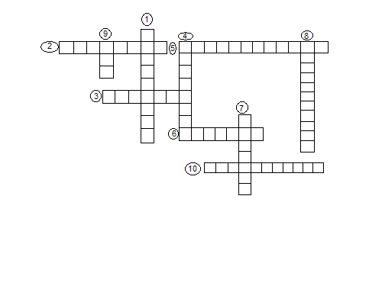
- Вещество, проводящее электрический ток.
- Устройство, создающее сопротивление току в цепи.
- Комплекс устройств, соединенных между собой, через которые протекает электрический ток.
- Самая малая отрицательная заряженная частица.
- ЭДС force.
- То, что состоит из нейтронов и протонов.
- Направленное движение заряженных частиц.
- Начало движения свободных электронов проводника, которые создают электрический ток.
- Атом с избытком и недостатком электронов.
- Ток бывает постоянным и …

