Соотнести фразы: например 1 G

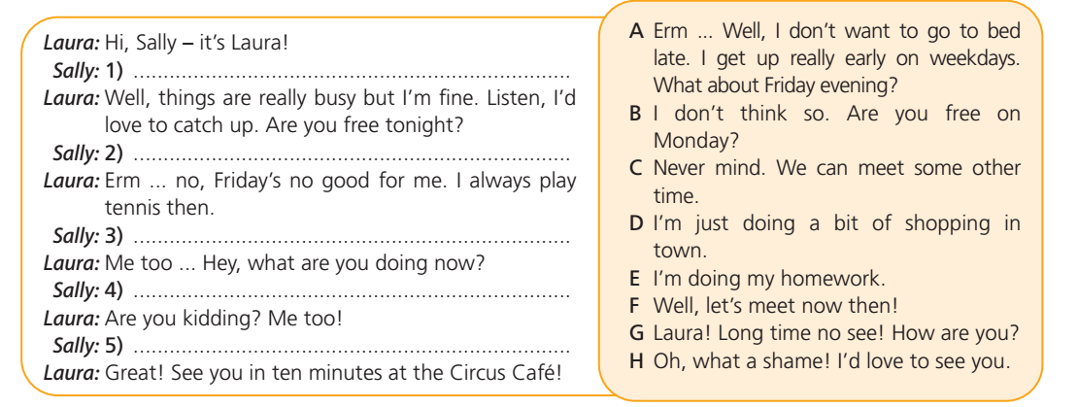

Языковые средства
Выбери подходящие слова.
Задание 16
There is a new carpet … the floor.
a) at b) in c) on
Задание 17
My friends … watch TV in the morning.
a) don’t b) doesn’t c) aren’t
Задание 18
– I’m cold.
– Have … tea.
a) any b) other c) some
Задание 19
Last year Robert’s parents … him a puppy.
a) buy b) bought c) buys
Задание 20
Please hurry up! We don’t have … time!
a) many b) much c) very
Задание 21
I like summer, because usually … warm and sunny.
a) it’s b) its c) it
Задание 22
What is ...? A train or a car?
a) faster b) more fast c) most faster
Задание 23
I’ve got a new ball. Let’s go and … football!
a) make b) do c) play
Задание 24
I’ll go to the baker’s to buy some … .
a) bread b) glue c) milk

