**Электрическая цепь. Electric Circuit**

Спишите новые слова из словаря

T1

1. Circuit [s : k i t] цепь, контур

2. Conductor [K n d k t ] проводник

3. Function [f k n] назначение

4. Difference [ d if r ns] разница

5. Open – обрыв

6. Short - короткое замыкание

7. Trouble [tr bl] повреждение

8. No [nou] никакой, нисколько

9. To reduce [ridju:s] сокращать

10. To supply [s plai] снабжать

11. To connect [k nekt] связывать

12. To compare (with) [k mp ] сравнивать (с)

13. To pass through [pa:s Oru:] проходить через

14. To result in - приводить к, иметь результатом

15. To result from - следовать , проистекать из.

T2

переведите

1. An open and short are troubles in a circuit.

2. A trouble in a circuit results in no current in it.

3. What does an open in a circuit result in?

4. What does a short in a circuit result in?

5. What does a trouble in a circuit result from?

**Прочитайте и переведите текст на русский язык**

Electric circuit.

This is a circuit. It is elements are a voltage source, a resistor and a

conductor. The circuit consists of a voltage source, a resistor and a

conductor. A voltage source supplies current. A resistor reduces current.

A conductor connects the elements of the circuit. Compare circuit a with

Circuit “b”. What is the difference between them? Circuit passes through

circuit “a” while no current passes through circuit “b”. Circuit

“b” has an open.

No current through circuit “b” results from an open. An open and a

short are troubles in a circuit.

Fig 1

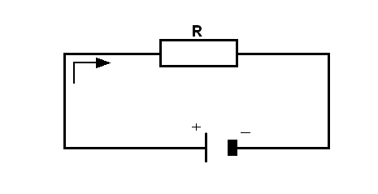

а)

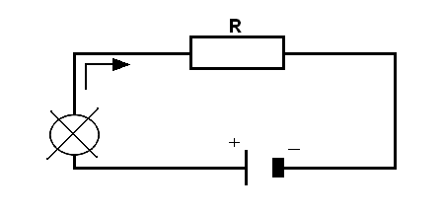

b)

**Дополните предложения используя один из вариантов ответов**

1. Circuit *a* consists of a) resistors and conductors.

b) a voltage source and resistors.

c) a voltage source, a resistor and a conductor.

2. A voltage source a) conducts current.

b) reduces current.

c) supplies current.

3. A conductor a) connects the elements.

b) supplies voltage.

c) conducts current.

4. A resistor a) connects the elements.

b) supplies current.

c) reduces current.

5. No current results from a) an open.

b) a short.

**Ответьте на вопросы**

1. What elements does a circuit consist of ?

2. What is the function of a voltage source?

3. What is the function of a conductor?

4. What is the function of a resistor?

5. When is there no current in a circuit?

6. What does an open or a short result in?

7. What does no current in a circuit result from?

Решите задачи.

1. How much is the current in the circuit if a 60-volt course is connected to a resistance of 1,600 ohms?

2. How much is the voltage in a circuit having a current equal to 20 amp, if a 25-ohm resistance is connected to it?

3. A 70.35-ohm resistance is connected to the circuit. How much is the voltage if he current equals 4.5 amp?

Pair work. compare circuits *a* and *b* (see Fig. 1).

1. What do they have in common?

2. Which of the circuits has a trouble?

3. What does the trouble result from?

4. What does it result in?