Электрический ток

Exercise 1. Прочитайте слова и переведите их без помощи словаря.
Nouns: theory, pole, electron, minute, effect, gas, cycle, distance.
Verbs: pass, generate.
Adjectives: static, positive, negative, opposite, industrial.

Exercise 2. Запишите и выучите слова и словосочетания.
determined - находящийся
direction - направление
the flow – поток
solids –тело(твердый)
liquids –жидкость
requirements – условия
the direct current –направление тока
the negatively charged terminal – отрицательно заряженный полюс
the positively charged terminal – положительно заряженный полюс
purposes is assumed – принятая цель
advantage - преимущество
vice versa - наоборот
Hence - следовательно

Exercise 3. Переведите текст со словарем на русский язык.

ELECTRIC CURRENT
Ever since Volta first produced a source of continuous current, men of science have been forming theories on this subject. For some time they could see no real difference between the newly-discovered phenomenon and the former understanding of static charges. Then the famous French scientist Ampere (after whom the unit of current was named) determined the difference between the current and the static charges. In addition to it, Ampere gave the current direction: he supposed the current to flow from the positive pole of the source round the circuit and back again to the negative pole.
We consider Ampere to be right in his first statement but he was certainly wrong in the second, as to the direction of the current. The student is certain to remember that the flow of current is in a direction opposite to what he thought. Let us turn our attention now to the electric current itself. The current which flows along wires consists of moving electrons. What can we say about the electron?
We know the electron to be a minute particle having an electric charge. We also know that that charge is negative. As these minute charges travel along a wire, that wire is said to carry an electric current.
In addition to travelling through solids, however, the electric current can flowthrough liquids as well and even through gases. In both cases it produces some most important effects to meet industrial requirements.
Some liquids, such as melted metals for example, conduct current without any change to themselves. Others, called electrolytes, are found to change greatly when the current passes through them.
When the electrons flow in one direction only, the current is known to be d. c., that is, direct current. The simplest source of power for the direct current is a battery, for a battery pushes the electrons in the same direction all the time (i.e., from the negatively charged terminal to the positively charged terminal).
The letters a.c. stand for alternating current. The current under consideration flows first in one direction and then in the opposite one, The a.c. used for power and lighting purposes is assumed to go through 50 cycles in one second. One of the great advantages of a.c. is the ease with which power at low voltage can be changed into an almost similar amount of power at high voltage and vice versa. Hence, on the one hand alternating voltage is increased when it is necessary for long-distance transmission and, on the other hand, one can decrease it to meet industrial requirements as well as to operate various devices at home.
Although there are numerous cases when d.c. is required, at least 90 per cent of electrical energy to be generated at present is a.c. In fact, it finds wide application for lighting, heating, industrial, and some other purposes. One cannot help mentioning here that Yablochkov, Russian scientist and inventor, was the first to apply a.c. in practice.

Exercise 4. Ответьте на вопросы по тексту.
- Who determined the difference between the current and the static charges?
- What can you say about the electron?
- What is the simplest source of power for the direct current?
- What is the great advantages of a.c.?
- Where does electrical energy apply?

Exercise 5. Переведите на русский язык словосочетания:
the newly-discovered phenomenon, the static charges, the positive pole, the direction of the current, the negative pole, the direct current, the negatively charged terminal, the positively charged terminal, low voltage, 50 cycles in one second, high voltage.
Exercises
I. Translate the following words:
runner, blade, level, magnitude, head, season; to influence, to fluctuate; i. e. = id est
II. (a, b) Translate the word-combinations in writing:
a) runner blade, blade size, runner blade size, water level, level change, water level change, level influence, water level change influence, turbine blades, water head, water head magnitude, fuel expenditure
b) water level fluctuations, thermal power plant, regional power plant, large industrial region supply, plant's power capacity, hydroelectric power plant production process
c) Answer the questions using the word-combinations given in (b):
1. What influences the plant's power capacity? 2. What plants serve for the supply of large industrial regions? 3. What plants serve for power supply in agricultural areas?
III. Fill in the verbs "to build", "to locate", "to fluctuate":
1. At what distance are hydroelectric power plants ... from their consumers? 2. Low-capacity power plants are ... in agricultural areas. 3. The daily inflow of water ... considerably.

TEXT. HYDROELECTRIC POWER PLANTS
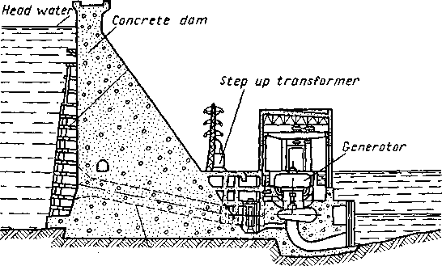
Fig. 15 – Cross-section through the main structures and units of hydroelectric power plant
Hydroelectric power plants are built on rivers. Large-capacity hydroelectric power plants are commonly located at considerable distances from the consumers of electric power.
The production process at these plants is rather simple: the water flows into the hydroturbine runner, acts upon the runner blades and rotates the runner and the turbine shaft.
The generator shaft is connected to the turbine runner shaft. The difference in the water level influences the power capacity of a plant, i. e. the magnitude of the water head and the daily inflow of water fluctuates considerably according to the season.
The production process is different at power plants of different constructions and of different kinds. In atomic power plants, for example, it is not so simple as in hydroelectric plants.
Exercises
IV. Choose the correct variant:
1. Large-capacity power plants are located a) at a short distance from consumers of power. b) at a considerable distance from consumers of power.
- Water rotates a) the runner blades, b) the turbine shaft.
- The magnitude of the water head a) influences the power capacity, b) does not influence it.
- Daily inflow of water a) fluctuates considerably, b) fluctuates a little.
V. Do you know…
that a thermal power plant seldom has an efficiency more than 35%?

Exercises
I. Translate the following words:
uranium, circulation, exchanger, dust, smoke, radiation, concrete; nuclear; to circulate, to pollute, to shield
II. Translate the word-combinations in writing:
a) energy rich area, smoke and dust polluted air, oil cooled device, steam utilizing machine, air heat exchanger, water cooling, cooling water, fuel polluted atmosphere, heat and water circulation, smoke shield
b) Answer the questions using the words given above:
1. In what area are industrial enterprises built commonly? 2.. What machine was invented by J. Watt? 3. What air is bad for one's health? 4. What kind of cooling is popular at electric power plants? 5. What type of heater is widely used nowadays?
TEXT. ATOMIC ELECTRIC POWER PLANT
Atomic power plants are modern installations. They consist of several main units and a great number of auxiliary ones.
In a nuclear reactor uranium is utilized as a fuel. During operation process powerful heat and radioactive radiation are produced. The nuclear reactor is cooled by water circulation. Cooling water circulates through a system of tubes, in which the water is heated to a temperature of 250-300°C. In order to prevent boiling of water, it passes into the reactor at a pressure up to 150 atmospheres.
A steam generator includes a series of heat exchangers comprising tubes. The water heated in the reactor is delivered into the heat exchanger tubes. The water to be converted into steam flows outside these tubes. The steam produced is fed into the turbogenerator.
Besides, an atomic power plant comprises a common turbogenerator, a steam condenser with circulating water and a switchboard.
Atomic power plants have their advantages as well as disadvantages. The reactors and steam generators operate in them noiselessly; the atmosphere is not polluted by dust and smoke. As to the fuel consumption, it is of no special importance and there is no problem of fuel transportation.
The disadvantage of power plants utilizing nuclear fuel is their radiation. Radioactive radiation produced in the reactors is dangerous for attending personnel. Therefore, the reactors and steam generators are installed underground. They are also shielded by thick (up to 1.5 m) concrete walls. All their controls are operated by means of automatic devices. These measures serve to protect people from radioactive radiation.
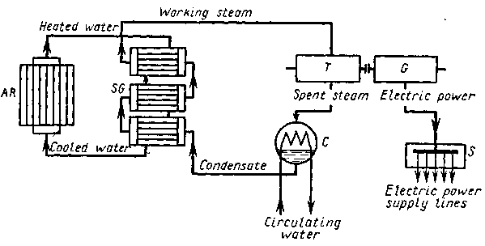

Fig. 16 – Simplified production process diagram of an atomic electric power plant:
AR – atomic reactor; SG – steam generator; T – steam turbine;
G – electric power generator; C – steam condenser; S - switchboard
Exercises
III. Choose the correct variant:
- A nuclear reactor is used in a) wind-power plants, b) atomic power plants.
- A nuclear reactor is cooled by a) water circulating in tubes, b) oil circulating in tubes.
- Water is passed into the reactor a) at a low pressure, b) at a high pressure.
- High pressure a) activates boiling of water, b) prevents boiling of water.
- Atomic power plants a) pollute the air with dust and smoke, b) do not pollute the air with dust and smoke.
- Circulating water flows a) inside the heat exchangers, b) outside the heat exchangers.
- Attending personnel is shielded by a) thick concrete walls, b) thick metal walls.
IV. Translate the text. Answer the questions given below:
1. Into what groups are all electric power consumers divided? 2. What consumers belong to the first (second, third) group? 3. In what way are electric power plants interconnected for operation? 4. What unit is called a power system? 5. By what means is an economical utilization of the power plant installations achieved?

