**ЗАДАНИЕ №3**

Прочтите и переведите текст на русский язык.

**Principle of Operation of the Four-Stroke Petrol Engine**

The internal combustion engine is called so because fuel is burned directly inside the engine itself. Most automobile engines work on a 4-stroke cycle. A cycle is one complete sequence of 4 strokes of the piston in the cylinder. The operating cycle of the four-stroke petrol engine includes: inlet stroke (intake valve opens), compression stroke (both valves closed), power stroke (both valves closed), exhaust stroke (exhaust valve is opened).

To describe the complete cycle, let's assume that the piston is at the top of the stroke (top dead center) and the inlet and the exhaust valves are closed. When the piston moves down the inlet valve opens to intake a charge of fuel into the cylinder. This is called the inlet (intake) stroke. On reaching the lowest position (bottom dead center) the pis­ton begins to move upward into the closed upper part on the cylinder, (he inlet valve is closed and the mixture is compressed by the rising piston. This is called the compression stroke. As the piston again reaches the top dead center the spark plugs ignite the mixture, both valves be­ing closed during its combustion. As a result of burning mixtures the both valves be­ing closed during its combustion. As a result of burning mixtures the gases expand and great pressure makes the piston move back down the cylinder. This stroke is called the power stroke. When the piston reaches the bottom of its stroke, the exhaust valve is opened, pressure is re­leased, and the piston again rises. It lets the burnt gas flow through the exhaust valve into the atmosphere. This is called the exhaust stroke which completes the cycle. So the piston moves in the cylinder down (intake stroke), up (compression stroke), down (power stroke), up (ex­haust stroke).

The heat released by the fuel is transformed into work so that the reciprocating movement of the pistons is converted into rotary move­ment of a crankshaft by means of connecting rods.

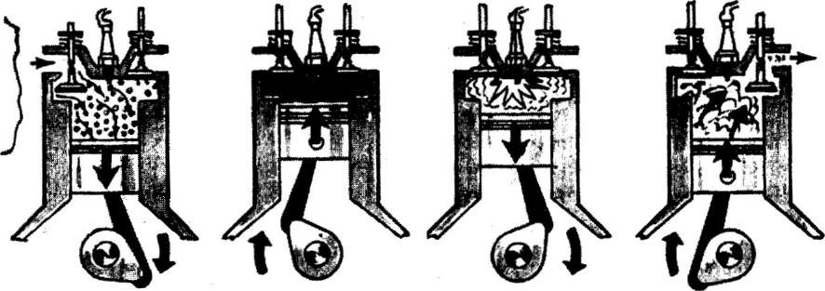

**1 - intake 2 - compression 3 - power 4 - exhaust**

***Рис. 1.* Principle of Operation of the Four-Stroke Petrol Engine**

1. intake - такт впуска 3. power — рабочий такт
2. compression — такт сжатия 4. exhaust — такт выхлопа

**bottom dead center** - нижняя мертвая точка

**charge of fuel** — заряд топлива

**combustion** — сгорание

**combustion chamber** – камера сгорания

**compression stroke** — такт сжатия(смеси)

**connecting rod** - шатун

**crankshaft**— коленчатый вал

**cylinder** - цилиндр

**diesel engine** — дизельный двигатель

**engine** — двигатель

**exhaust stroke** — такт выпуска

**four-stroke cycle** — четырехтактный цикл

**fuel injection** — впрыск топлива

**ignite** — воспламенять

**ignition**— воспламенение

**intake (inlet) stroke** — такт впуска

**internal combustion engine** – двигатель внутреннего сгорания

**mixture** — смесь

**operating cycle** - рабочий цикл

**petrol engine** — бензиновый двигатель

**piston**— поршень

**power stroke** — рабочий ход

**pressure** - давление

**reciprocating movement** — возвратно-поступательное движение

**residual gas** — остаточный газ

**rotary movement** — вращательное движение

**spark plug** — свеча зажигания

**stroke** — ход (поршня);

**top dead center** — верхняя мертвая точка

**valve** - клапан

Найдите в тексте ответы на вопросы.

* 1. 1. Why is the engine called the internal combustion engine?
  2. 2. What stroke is called the inlet one?
  3. 3. What is a compression stroke?
  4. 4. What takes place in the cylinder on power stroke?
  5. 5. By means of what is the reciprocating movement of the pistons converted into rotary movement of a crankshaft?
  6. 6. What takes place on the exhaust stroke?