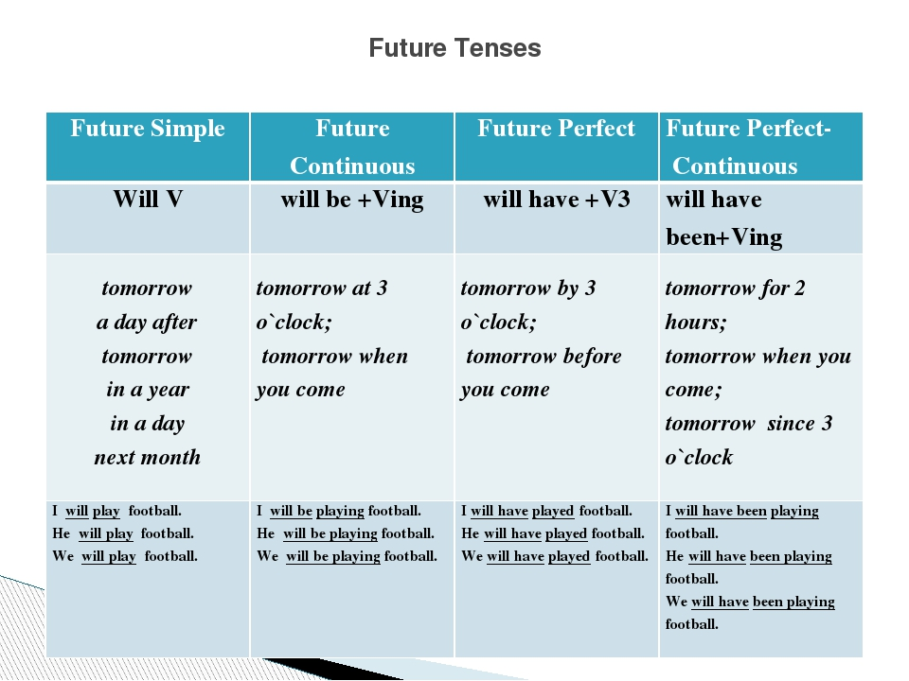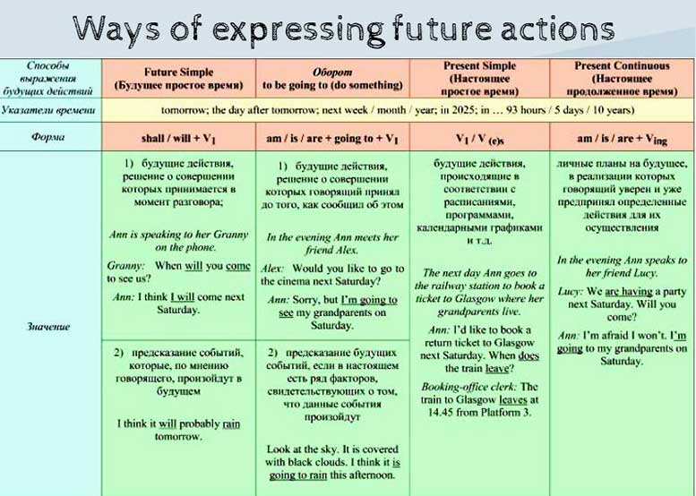

Упражнение 1. Поставьте глаголы в следующих предложениях в утвердительную, вопросительную и отрицательную формы Future Simple.
1ПРИМЕР. I (to do) morning exercises. I shall do morning exercises/ I Shan’t do morning exercises/ Shall I do morning execises?
2. He (to work) at a factory.
3. She (to sleep) after dinner.
4. We (to work) part-time.
5. They (to drink) tea every day.
6. Mike (to be) a student.
7. Helen (to have) a car.
8. You (to be) a good friend.
9. You (to be) good friends.
10. It (to be) difficult to remember everything.

Упражнение 2. Раскройте скобки, употребляя глаголы в Future Simple.
1. Alice (to have) a sister. Alice will have a sister.
2. Her sister’s name (to be) Ann.
3. Ann (to be) a student.
4. She (to get) up at seven o'clock.
5. She (to go) to the institute in the morning.
6. Jane (to be) fond of sports.
7. She (to do) her morning exercises every day.
8. For breakfast she (to have) two eggs, a sandwich and a cup of tea.
9. After breakfast she (to go) to the institute.
10. Sometimes she (to take) a bus.
11. It (to take) her an hour and a half to do her homework.
12. She (to speak) English well.
13. Her friends usually (to call) her at about 8 o’clock.
14. Ann (to take) a shower before going to bed.
15. She (to go) to bed at 11 p. m.

Упражнение 3. Раскройте скобки, употребляя глаголы в Future Simple.
1. My working day (to begin) at six o'clock.
2. I (to get) up, (to switch) on the TV and (to brush) my teeth.
3. It (to take) me about twenty minutes.
4. I (to have) breakfast at seven o’clock.
5. I (to leave) home at half past seven.
6. I (to take) a bus to the institute.
7. It usually (to take) me about fifteen minutes to get there.
8. Classes (to begin) at eight.
9. We usually (to have) four classes a day.
10. I (to have) lunch at about 2 o’clock.

Упражнение 4. Используйте слова в скобках для образования предложений в Future Simple. Обратите внимание, в какой форме должно стоять предложение (утвердительной, вопросительной или отрицательной).
1) They _____ football at the institute. (to play)
2) She won’t write emails. (not / to write)
3) ПРИМЕР Will you speak English? (to speak)
4) My mother ____ fish. (not / to like)
5) ____ Ann ____ any friends? (to have)
6) His brother _____ in an office. (to work)
7) She ___ very fast. (cannot / to read)
8) ____ they ____ the flowers every 3 days? (to water)
9) His wife _____ a motorbike. (not / to ride)
10) ____ Elizabeth_____ coffee? (to drink)

Упражнение 5. Переведите на английский язык:
1. Она будет занята. (to be busy)
2. Я не буду занят.
3. Вы будете заняты?
4. Они будут дома? (to be at home)
5. Его не будет дома.
6. Я не буду знать.
7. Они будут знать?
8. Она не будет знать.
9. Кто будет знать?
10. Никто не будет знать.
11. Он будет читать английские книги? (to read English books)
12. Они никогда не будут читать. (never / to read)
13. У неё будет квартира? (to have a flat)
14. У него ничего не будет.
15. Кто это будет?

